Tour 2, Stationen 5/6: Lettow-Vorbeck-Kaserne I und II

https://orte-der-unsichtbarkeit.de/station/lettow-vorbeck-kaserne-i/
Die Mauer mit dem Schriftzug „Lettow-Vorbeck-Kaserne“ ist noch erhalten und befindet sich direkt am Eingang zu den ehemaligen Kasernengebäuden (Copyright: Jan Krawczyk)

Was erfahrt ihr über den Ort Lettow-Vorbeck-Kaserne?

_______________________________________________________________________________________

_______________________________________________________________________________________

_______________________________________________________________________________________

_______________________________________________________________________________________

Was hat dieser Ort mit der DDR zu tun?

_______________________________________________________________________________________

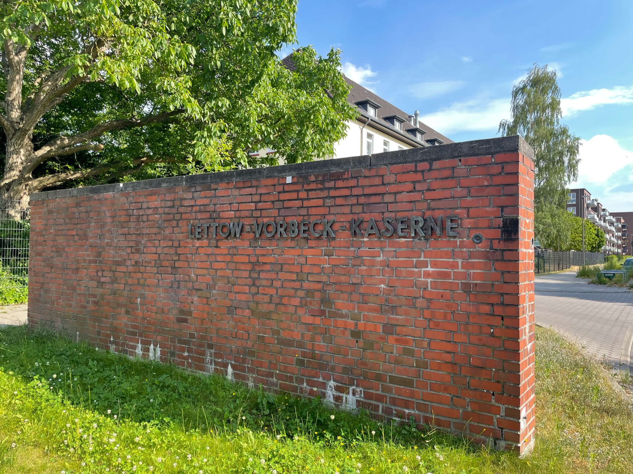
_______________________________________________________________________________________
Aufgabe: Hört und schaut euch die Stationen Lettow-Vorbeck-Kaserne I und II an. Beantwortet die folgenden Fragen in Stichworten.

_______________________________________________________________________________________

_______________________________________________________________________________________

Welches Thema findet ihr an diesem Ort besonders wichtig?

_______________________________________________________________________________________

_______________________________________________________________________________________

_______________________________________________________________________________________

_______________________________________________________________________________________

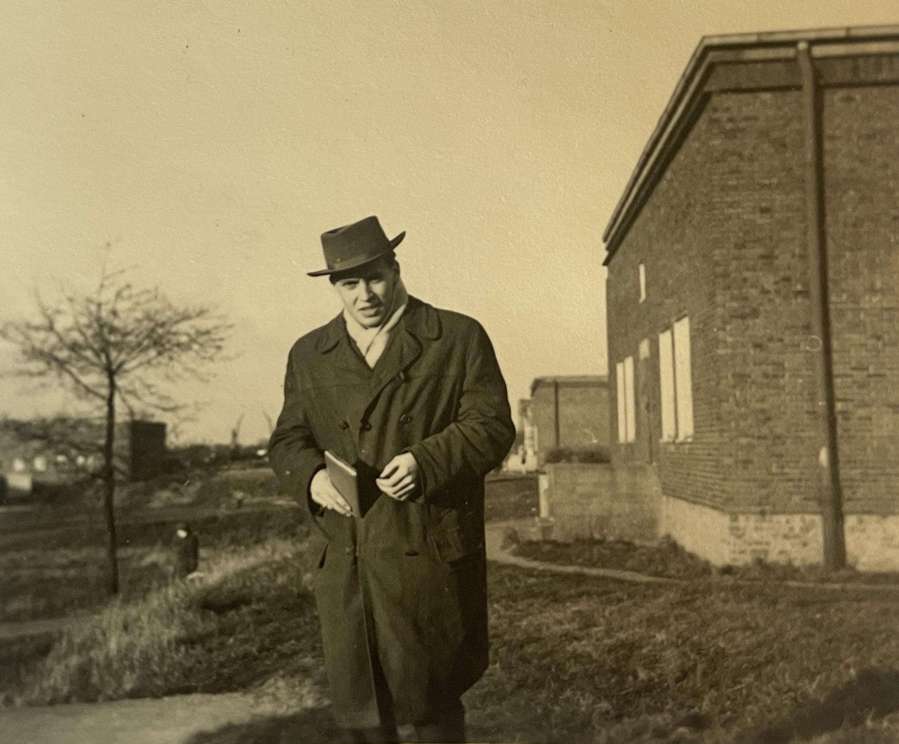
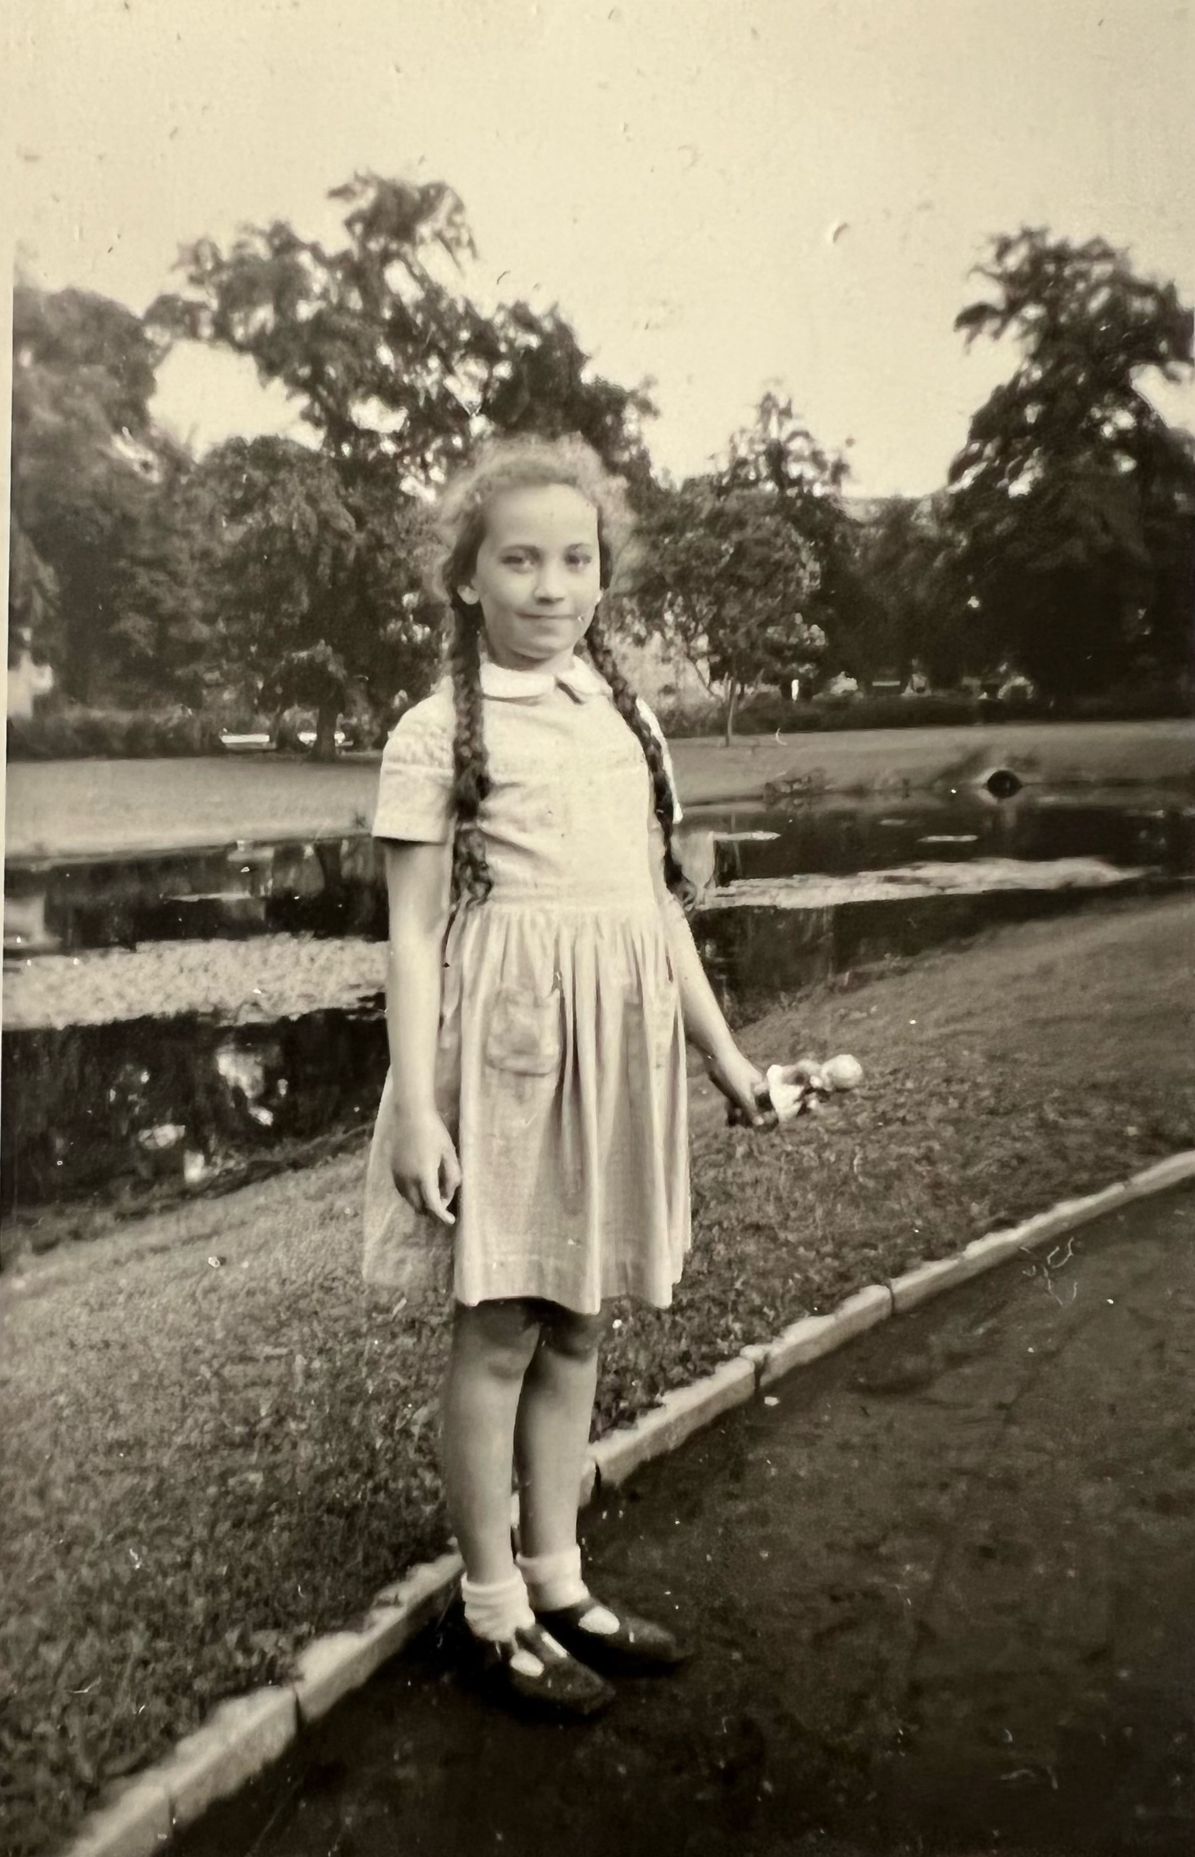

Einige Zeitzeug:innen haben etwas zur Lettow-Vorbeck-Kaserne zu sagen. Was sind die Erinnerungen und Erfahrungen von Gitte und Manfred K.? Aufgabe: Tragt in die Sprechblasen ein, was die Personen zur Lettow-Vorbeck-Kaserne sagen.
Gitte kurz nach ihrer Ankunft in Hamburg 1954 (Copyright: Zeitzeugin Gitte)
Manfred K. im Durchgangslager Finkenwerder 1955 (Copyright: Zeitzeuge Manfred K.)

Aufgabe: Entscheidet euch nun für eine Person und beantwortet folgende Fragen:

Wie haben die Personen die DDR wahrgenommen? Wie beschreiben sie ihre Lebensverhältnisse?

_______________________________________________________________________________________

_______________________________________________________________________________________

_______________________________________________________________________________________

_______________________________________________________________________________________

Wann und wie sind die Personen aus der DDR nach Hamburg gekommen?

_______________________________________________________________________________________

_______________________________________________________________________________________

_______________________________________________________________________________________

_______________________________________________________________________________________
https://orte-der-unsichtbarkeit.de/zeitzeuginnen/

_______________________________________________________________________________________

_______________________________________________________________________________________

_______________________________________________________________________________________

War/ist Hamburg für die Personen ein Sehnsuchtsort?

_______________________________________________________________________________________

_______________________________________________________________________________________

_______________________________________________________________________________________

_______________________________________________________________________________________

_______________________________________________________________________________________

_______________________________________________________________________________________

_______________________________________________________________________________________

_______________________________________________________________________________________

_______________________________________________________________________________________

_______________________________________________________________________________________

_______________________________________________________________________________________

_______________________________________________________________________________________

_______________________________________________________________________________________

_______________________________________________________________________________________

_______________________________________________________________________________________

_______________________________________________________________________________________

_______________________________________________________________________________________

_______________________________________________________________________________________
Aufgabe: Welche Themen lassen sich eurer Person zuordnen? Entscheidet euch für ein Thema der Infobox und begründet eure Antwort.

_______________________________________________________________________________________

_______________________________________________________________________________________

_______________________________________________________________________________________
Aufgabe: Hier könnt ihr notieren, was ihr noch nicht verstanden habt oder ihr sonst noch an der Station spannend findet.

_______________________________________________________________________________________

_______________________________________________________________________________________

_______________________________________________________________________________________

_______________________________________________________________________________________

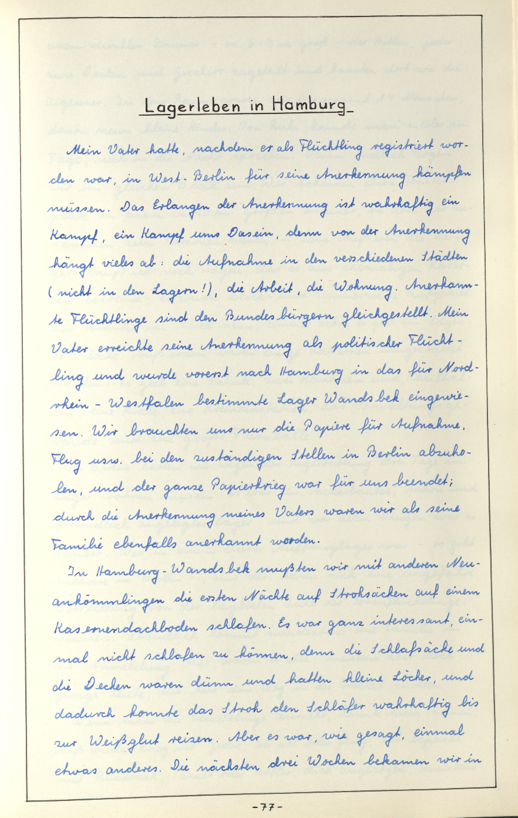
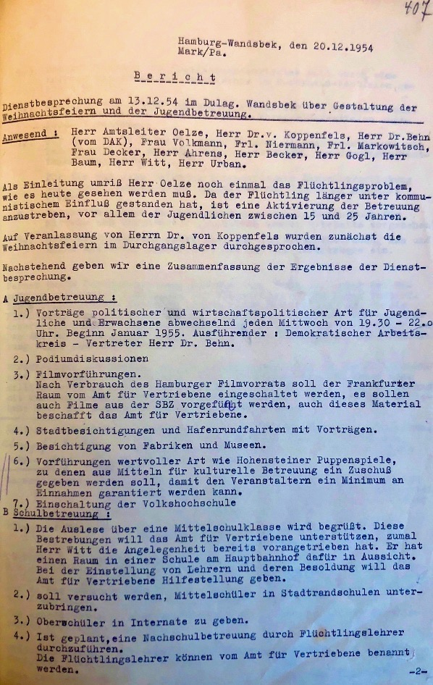
Persönlicher Bericht eines Zeitzeugen, der als Jugendlicher für einen Schulaufsatz über das Ankommen im Lager in Wandsbek schreibt. (Copyright: Zeitzeugin Marlen)
Bericht einer Dienstbesprechung vom 13. Dezember 1954 über den Umgang mit Jugendlichen, die im Durchgangslager Wandsbek untergebracht waren. (Copyright: Staatsarchiv Hamburg, Durchgangslager Hamburg-Wandsbek (Estorff-Kaserne und Lettow-Vorbeck-Kaserne), Kelloggstraße 94.- Allgemeines: Band 3, Nr. 4232)

_______________________________________________________________________________________

_______________________________________________________________________________________

_______________________________________________________________________________________

_______________________________________________________________________________________

_______________________________________________________________________________________

_______________________________________________________________________________________

_______________________________________________________________________________________

_______________________________________________________________________________________

_______________________________________________________________________________________

_______________________________________________________________________________________

_______________________________________________________________________________________

_______________________________________________________________________________________

_______________________________________________________________________________________

_______________________________________________________________________________________
Aufgabe: Ordnet die abgedruckten Quellen vor dem Hintergrund der Station, der Infoboxen und der Geschichte der Person ein.

_______________________________________________________________________________________

_______________________________________________________________________________________

_______________________________________________________________________________________

_______________________________________________________________________________________

_______________________________________________________________________________________

_______________________________________________________________________________________

_______________________________________________________________________________________

_______________________________________________________________________________________

_______________________________________________________________________________________

_______________________________________________________________________________________

