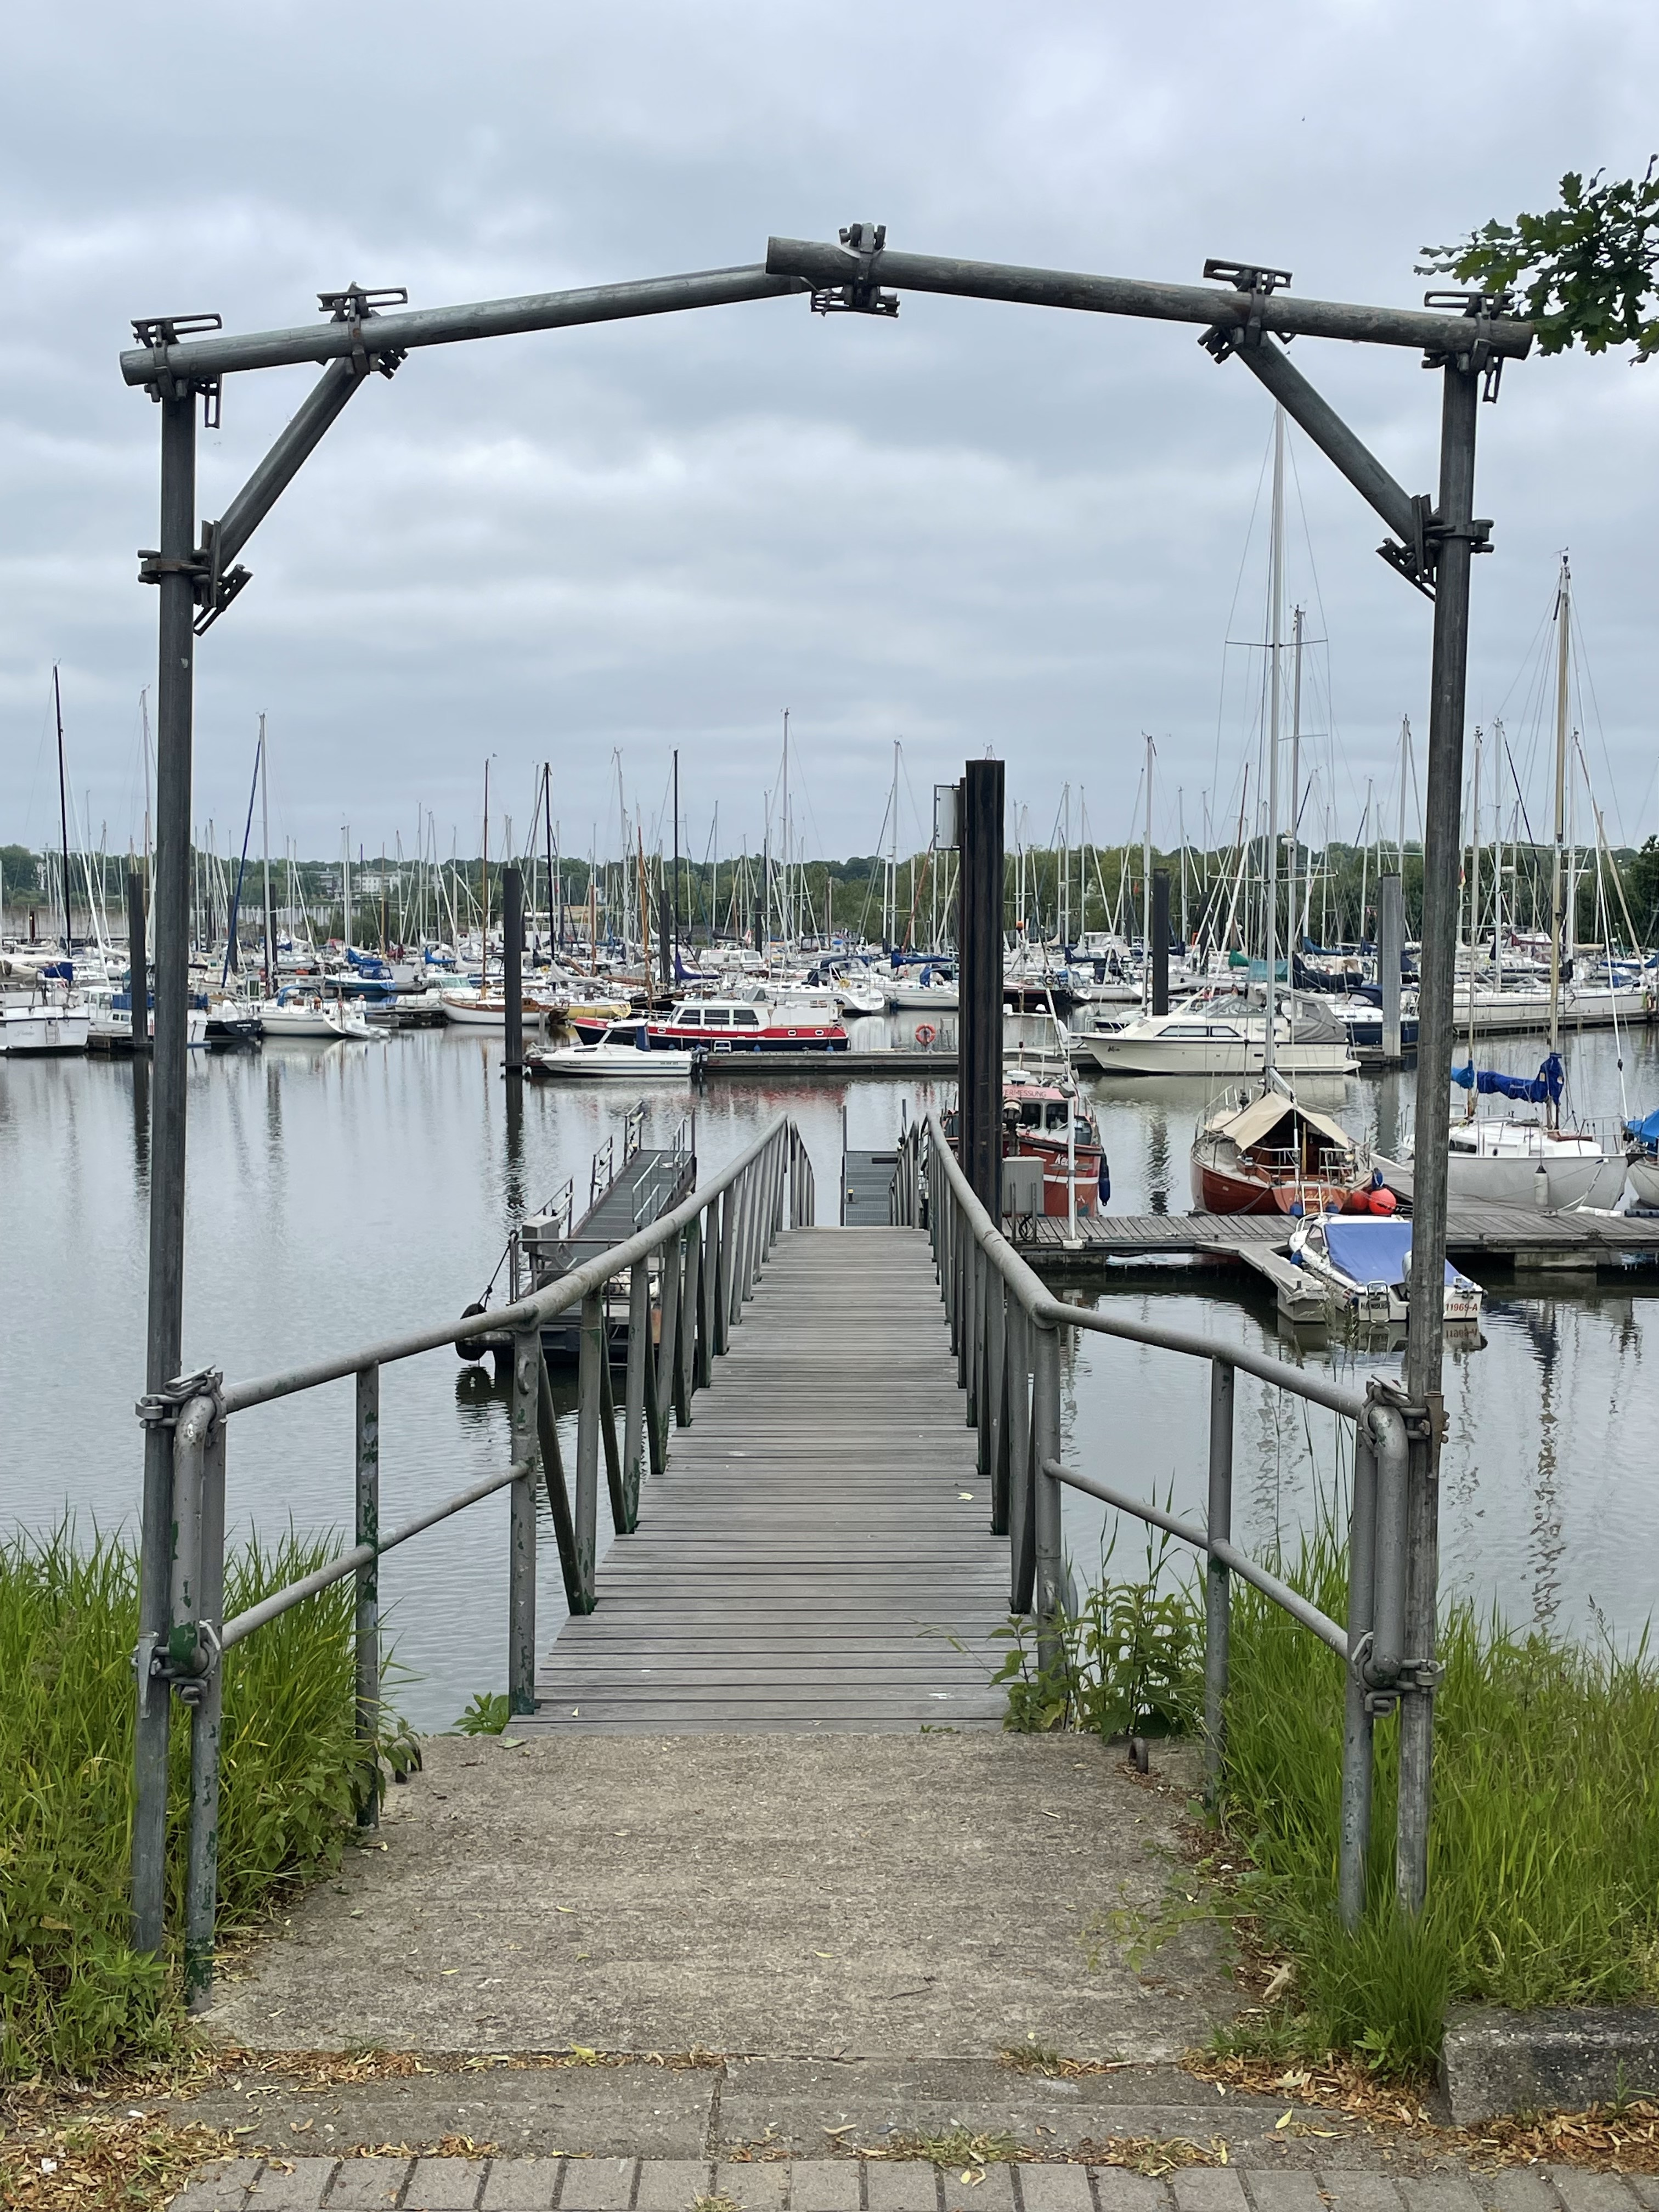
Tour 3, Station 9: Finkenwerder

Der Steg, der vormals der Fähranleger direkt am Durchgangslager Finkenwerder war (Copyright: Theresa Hertrich)
https://orte-der-unsichtbarkeit.de/station/finkenwerder/

Was erfahrt ihr über den Ort Finkenwerder?

_______________________________________________________________________________________

_______________________________________________________________________________________

_______________________________________________________________________________________

_______________________________________________________________________________________

Was hat dieser Ort mit der DDR zu tun?

_______________________________________________________________________________________

_______________________________________________________________________________________
Aufgabe: Hört und schaut euch die Station Finkenwerder an. Beantwortet die folgenden Fragen in Stichworten.

_______________________________________________________________________________________

_______________________________________________________________________________________

Welches Thema findet ihr an diesem Ort besonders wichtig?

_______________________________________________________________________________________

_______________________________________________________________________________________

_______________________________________________________________________________________

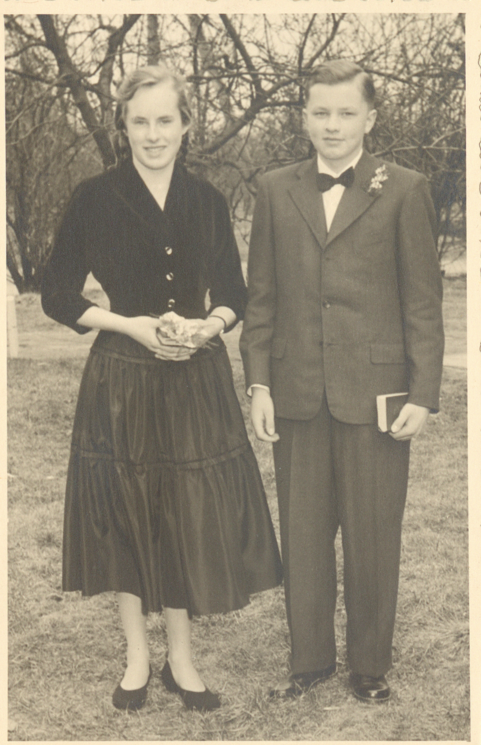

https://orte-der-unsichtbarkeit.de/zeitzeuginnen/

Marlen mit ihrem Bruder Hans Joachim bei ihrer Konfirmation in Finkenwerder 1956 (Copyright: Zeitzeugin Marlen)

Wie hat Marlen die DDR wahrgenommen? Wie beschreibt sie ihre Lebensverhältnisse?

_______________________________________________________________________________________

_______________________________________________________________________________________

_______________________________________________________________________________________

_______________________________________________________________________________________

Einige Zeitzeug:innen haben etwas zu Finkenwerder zu sagen. Was sind die Erinnerungen und Erfahrungen von Marlen? Aufgabe: Tragt in die Sprechblasen ein, was Marlen zu Finkenwerder zu sagen hat.
Aufgabe: Beantwortet folgende Fragen zur Person:

Wann und wie ist Marlen aus der DDR nach Hamburg gekommen?

_______________________________________________________________________________________

_______________________________________________________________________________________

_______________________________________________________________________________________

_______________________________________________________________________________________

_______________________________________________________________________________________

_______________________________________________________________________________________

_______________________________________________________________________________________

_______________________________________________________________________________________

_______________________________________________________________________________________

_______________________________________________________________________________________

_______________________________________________________________________________________

War/ist Hamburg für Marlen ein Sehnsuchtsort?

_______________________________________________________________________________________

_______________________________________________________________________________________

_______________________________________________________________________________________

_______________________________________________________________________________________

_______________________________________________________________________________________
Aufgabe: Welche Themen lassen sich Marlen zuordnen? Entscheidet euch für ein Thema der Infobox und begründet eure Antwort.
_______________________________________________________________________________________

_______________________________________________________________________________________

_______________________________________________________________________________________

_______________________________________________________________________________________

_______________________________________________________________________________________

_______________________________________________________________________________________

_______________________________________________________________________________________

_______________________________________________________________________________________

_______________________________________________________________________________________

_______________________________________________________________________________________

_______________________________________________________________________________________

_______________________________________________________________________________________

_______________________________________________________________________________________

_______________________________________________________________________________________

_______________________________________________________________________________________

_______________________________________________________________________________________

_______________________________________________________________________________________

_______________________________________________________________________________________

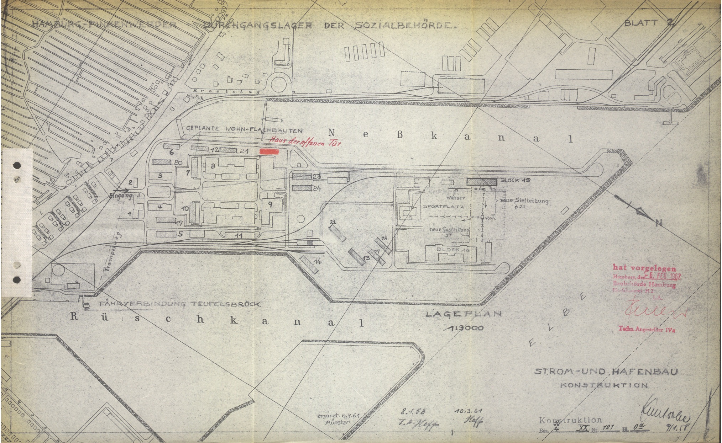
_______________________________________________________________________________________
Aufgabe: Hier könnt ihr notieren, was ihr noch nicht verstanden habt oder ihr sonst noch an der Station spannend findet.
Aufgabe: Ordnet die abgedruckte Quelle vor dem Hintergrund der Station, der Infoboxen und der Geschichte der Person ein.
Der Entlassungschein von Henriette (Copyright: Zeitzeugin Henriette)
Lageplan des Durchgangslagers Finkenwerder aus dem Jahr 1962. Eingezeichnet ist auch die Fährverbindung nach Teufelsbrück (Copyright: Staatsarchiv Hamburg: Lageplan Durchgangslager Finkenwerder 1962, 321-3 I_239)

