Tour 1, Station 8: Linie 62

Der Fähranleger der Linie 62 an den Landungsbrücken (Copyright: Theresa Hertrich)

Was erfahrt ihr über die Linie 62?

_______________________________________________________________________________________

_______________________________________________________________________________________

_______________________________________________________________________________________

_______________________________________________________________________________________

Was hat dieser Ort mit der DDR zu tun?

_______________________________________________________________________________________

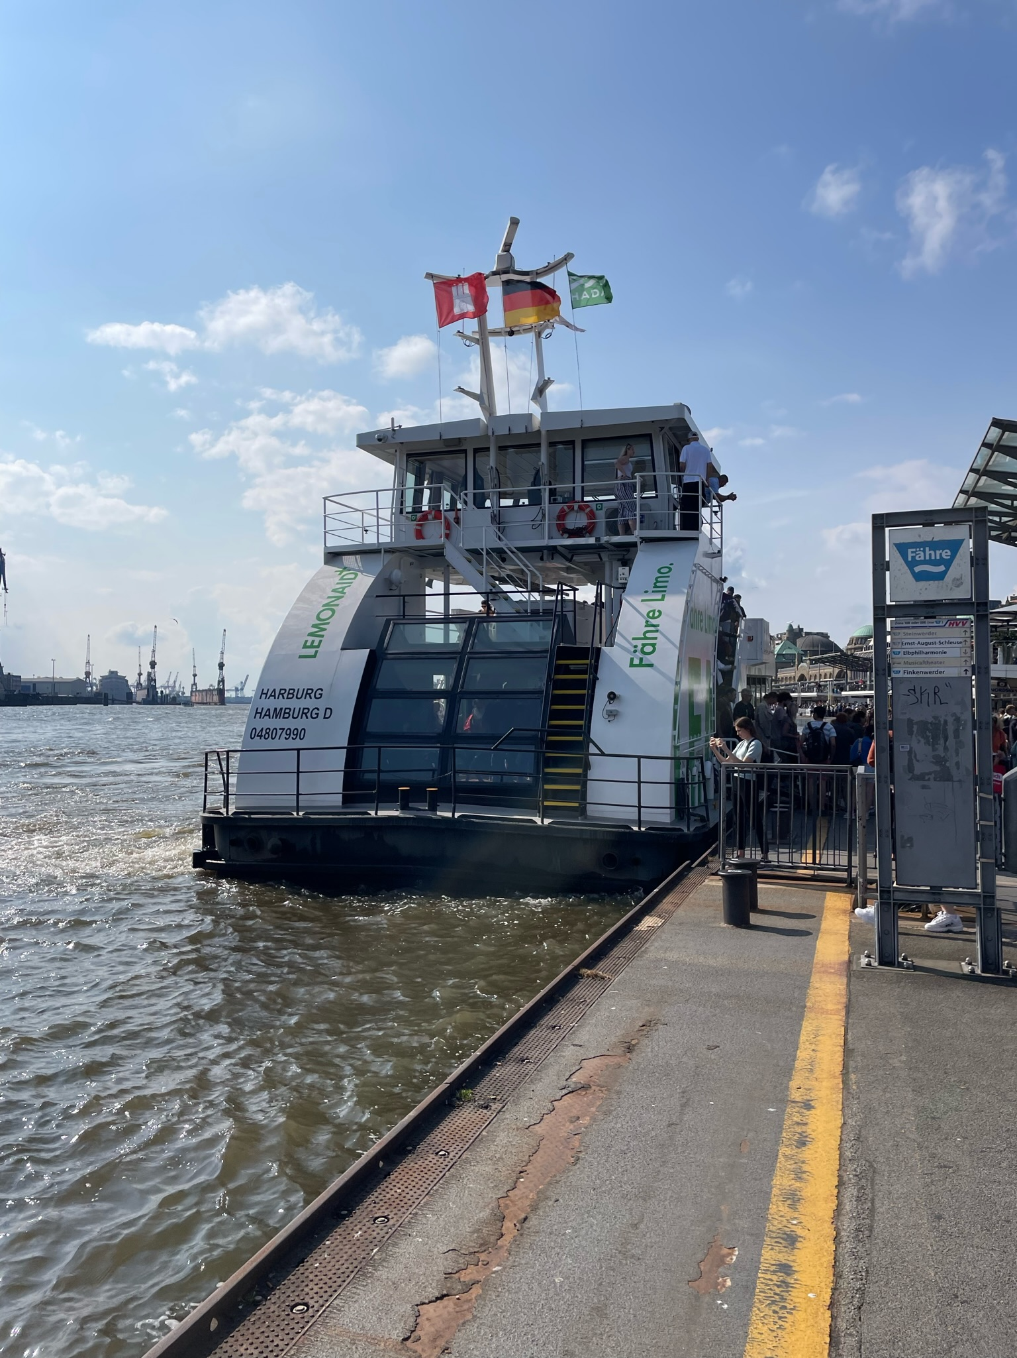
_______________________________________________________________________________________
https://orte-der-unsichtbarkeit.de/station/linie-62/
Aufgabe: Hört und schaut euch die Station Linie 62 an. Beantwortet die folgenden Fragen in Stichworten.

_______________________________________________________________________________________

_______________________________________________________________________________________

Welches Thema findet ihr an diesem Ort besonders wichtig?

_______________________________________________________________________________________

_______________________________________________________________________________________

_______________________________________________________________________________________

_______________________________________________________________________________________

Wie hat Richard die DDR wahrgenommen? Wie beschreibt er seine Lebensverhältnisse?

_______________________________________________________________________________________

_______________________________________________________________________________________

_______________________________________________________________________________________

_______________________________________________________________________________________

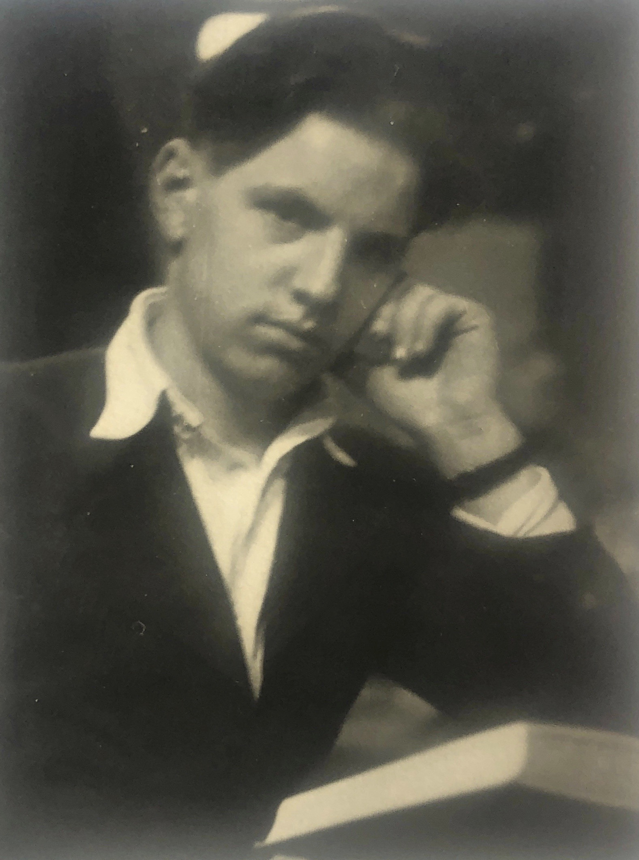
Wann und wie ist Richard aus der DDR nach Hamburg gekommen?

Einige Zeitzeug:innen haben etwas zur Linie 62 und der Elbe zu sagen. Was sind die Erinnerungen und Erfahrungen von Richard? Aufgabe: Tragt in die Sprechblasen ein, was Richard zur Linie 62 zu sagen hat.
Aufgabe: Beantwortet folgende Fragen zur Person:
Richard in den 1950er Jahren (Copyright: Zeitzeuge Richard)
https://orte-der-unsichtbarkeit.de/zeitzeuginnen/

_______________________________________________________________________________________

_______________________________________________________________________________________

_______________________________________________________________________________________

_______________________________________________________________________________________

_______________________________________________________________________________________

_______________________________________________________________________________________

_______________________________________________________________________________________

_______________________________________________________________________________________

War/ist Hamburg für Richard ein Sehnsuchtsort?

_______________________________________________________________________________________

_______________________________________________________________________________________

_______________________________________________________________________________________

_______________________________________________________________________________________

_______________________________________________________________________________________

_______________________________________________________________________________________

_______________________________________________________________________________________

_______________________________________________________________________________________
Aufgabe: Hier könnt ihr notieren, was ihr noch nicht verstanden habt oder ihr sonst noch an der Station spannend fandet.

_______________________________________________________________________________________

_______________________________________________________________________________________

_______________________________________________________________________________________

_______________________________________________________________________________________

_______________________________________________________________________________________

_______________________________________________________________________________________

_______________________________________________________________________________________

_______________________________________________________________________________________

_______________________________________________________________________________________

_______________________________________________________________________________________

_______________________________________________________________________________________

