Tour 1, Station 3: Jungfernstieg
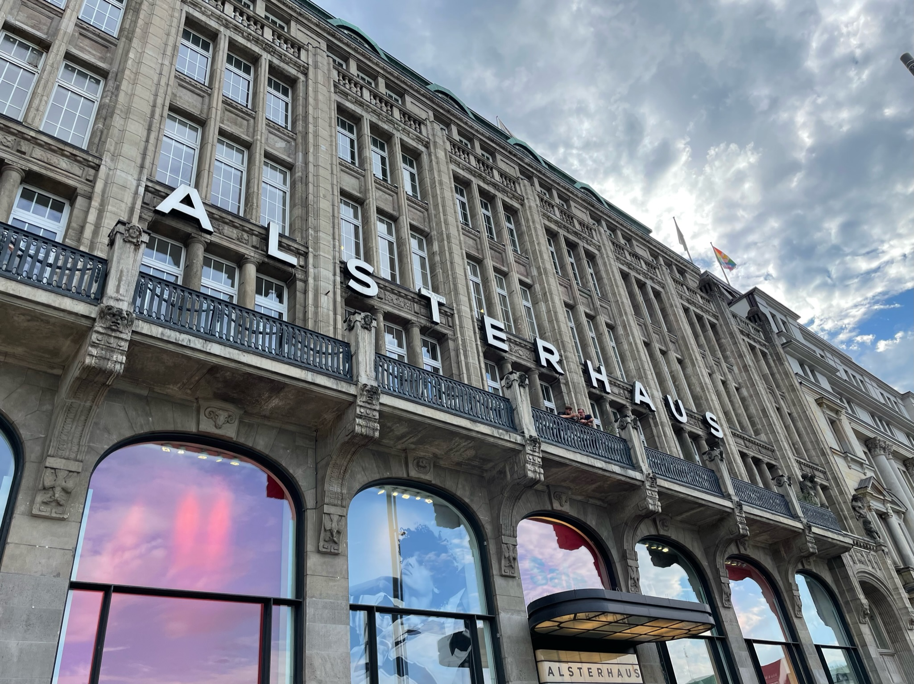

Aktuelle Aufnahme des Alsterhauses (Copyright: Theresa Hertrich)
https://orte-der-unsichtbarkeit.de/station/jungfernstieg/

Was erfahrt ihr über den Ort Jungfernstieg?

_______________________________________________________________________________________

_______________________________________________________________________________________

_______________________________________________________________________________________

_______________________________________________________________________________________

Was hat dieser Ort mit der DDR zu tun?

_______________________________________________________________________________________

_______________________________________________________________________________________
Aufgabe: Hört und schaut euch die Station Jungfernstieg an. Beantwortet die folgenden Fragen in Stichworten.

_______________________________________________________________________________________

_______________________________________________________________________________________

Welches Thema findet ihr an diesem Ort besonders wichtig?

_______________________________________________________________________________________

_______________________________________________________________________________________

_______________________________________________________________________________________

_______________________________________________________________________________________

Wie hat Eckhard die DDR wahrgenommen? Wie beschreibt er seine Lebensverhältnisse?

_______________________________________________________________________________________

_______________________________________________________________________________________

_______________________________________________________________________________________

_______________________________________________________________________________________

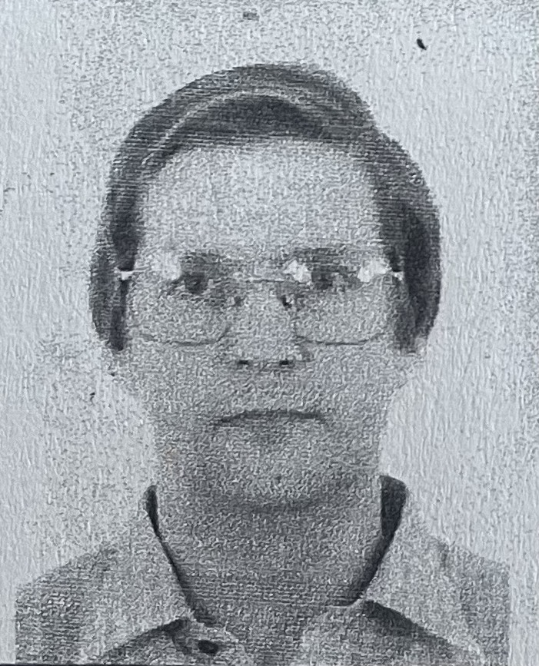
Wann und wie ist Eckhard aus der DDR nach Hamburg gekommen?

Einige Zeitzeug:innen haben etwas am Jungfernstieg zu sagen. Was sind die Erinnerungen und Erfahrungen von Eckhard? Aufgabe: Tragt in die Sprechblasen ein, was Eckhard zum Jungfernstieg zu sagen hat.
Aufgabe: Beantwortet folgende Fragen zur Person:
Eckhard kurz nach seiner Entlassung aus der politischen Haft 1982 (Copyright: Zeitzeuge Eckhard)
https://orte-der-unsichtbarkeit.de/zeitzeuginnen/

_______________________________________________________________________________________

_______________________________________________________________________________________

_______________________________________________________________________________________

_______________________________________________________________________________________

_______________________________________________________________________________________

_______________________________________________________________________________________

_______________________________________________________________________________________

_______________________________________________________________________________________

_______________________________________________________________________________________

_______________________________________________________________________________________

_______________________________________________________________________________________

War/ist Hamburg für Eckhard ein Sehnsuchtsort?

_______________________________________________________________________________________

_______________________________________________________________________________________

_______________________________________________________________________________________

_______________________________________________________________________________________

_______________________________________________________________________________________

_______________________________________________________________________________________
Aufgabe: Hier könnt ihr notieren, was ihr noch nicht verstanden habt oder ihr sonst noch an der Station spannend findet.

_______________________________________________________________________________________

_______________________________________________________________________________________

_______________________________________________________________________________________

_______________________________________________________________________________________

_______________________________________________________________________________________

_______________________________________________________________________________________

_______________________________________________________________________________________

_______________________________________________________________________________________

_______________________________________________________________________________________

