Tour 1, Station 2: Trostbrücke 1
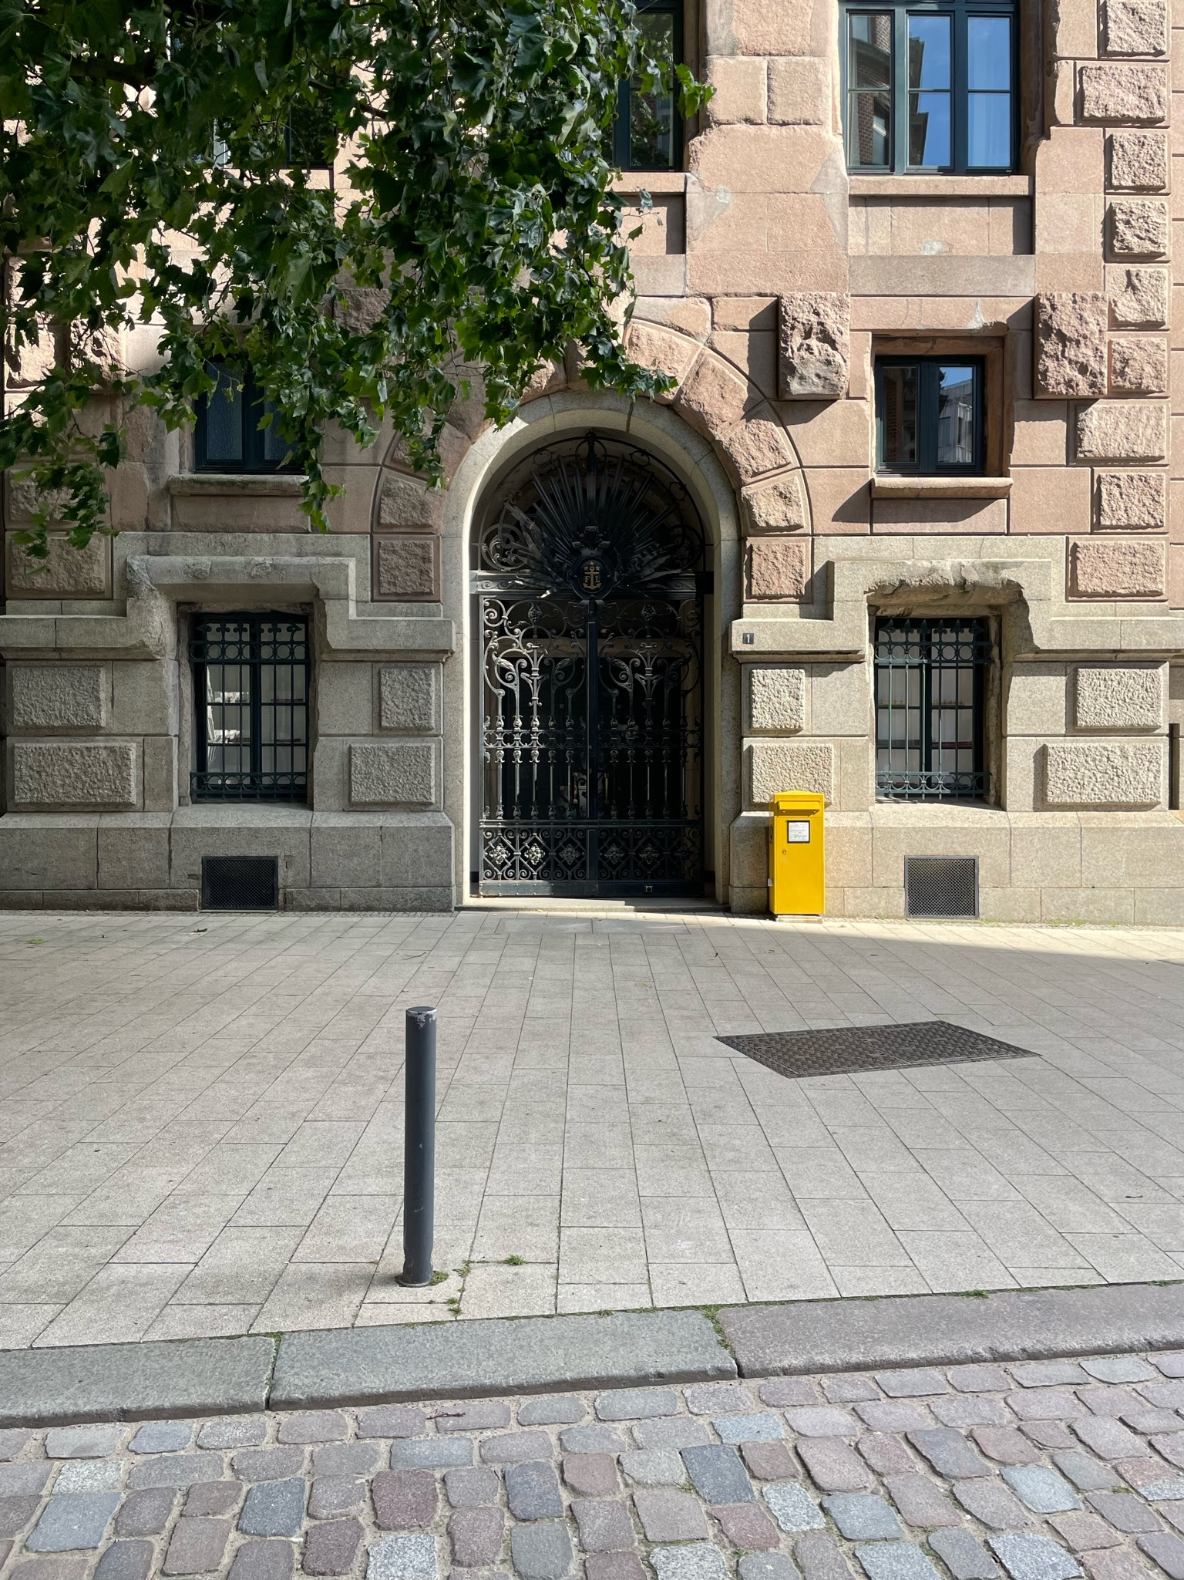

Aktuelle Aufnahme der Trostbrücke 1 (Copyright: Theresa Hertrich)

Was erfahrt ihr über den Ort Trostbrücke 1?

_______________________________________________________________________________________

_______________________________________________________________________________________

_______________________________________________________________________________________

_______________________________________________________________________________________

Was hat dieser Ort mit der DDR zu tun?

_______________________________________________________________________________________

_______________________________________________________________________________________
https://orte-der-unsichtbarkeit.de/station/trostbruecke/
Aufgabe: Hört und schaut euch die Station Trostbrücke 1 an. Beantwortet die folgenden Fragen in Stichworten.

_______________________________________________________________________________________

_______________________________________________________________________________________

Welches Thema findet ihr an diesem Ort besonders wichtig?

_______________________________________________________________________________________

_______________________________________________________________________________________

_______________________________________________________________________________________

_______________________________________________________________________________________

Wie hat Henriette die DDR wahrgenommen? Wie beschreibt sie ihre Lebensverhältnisse?

_______________________________________________________________________________________

_______________________________________________________________________________________

_______________________________________________________________________________________

_______________________________________________________________________________________

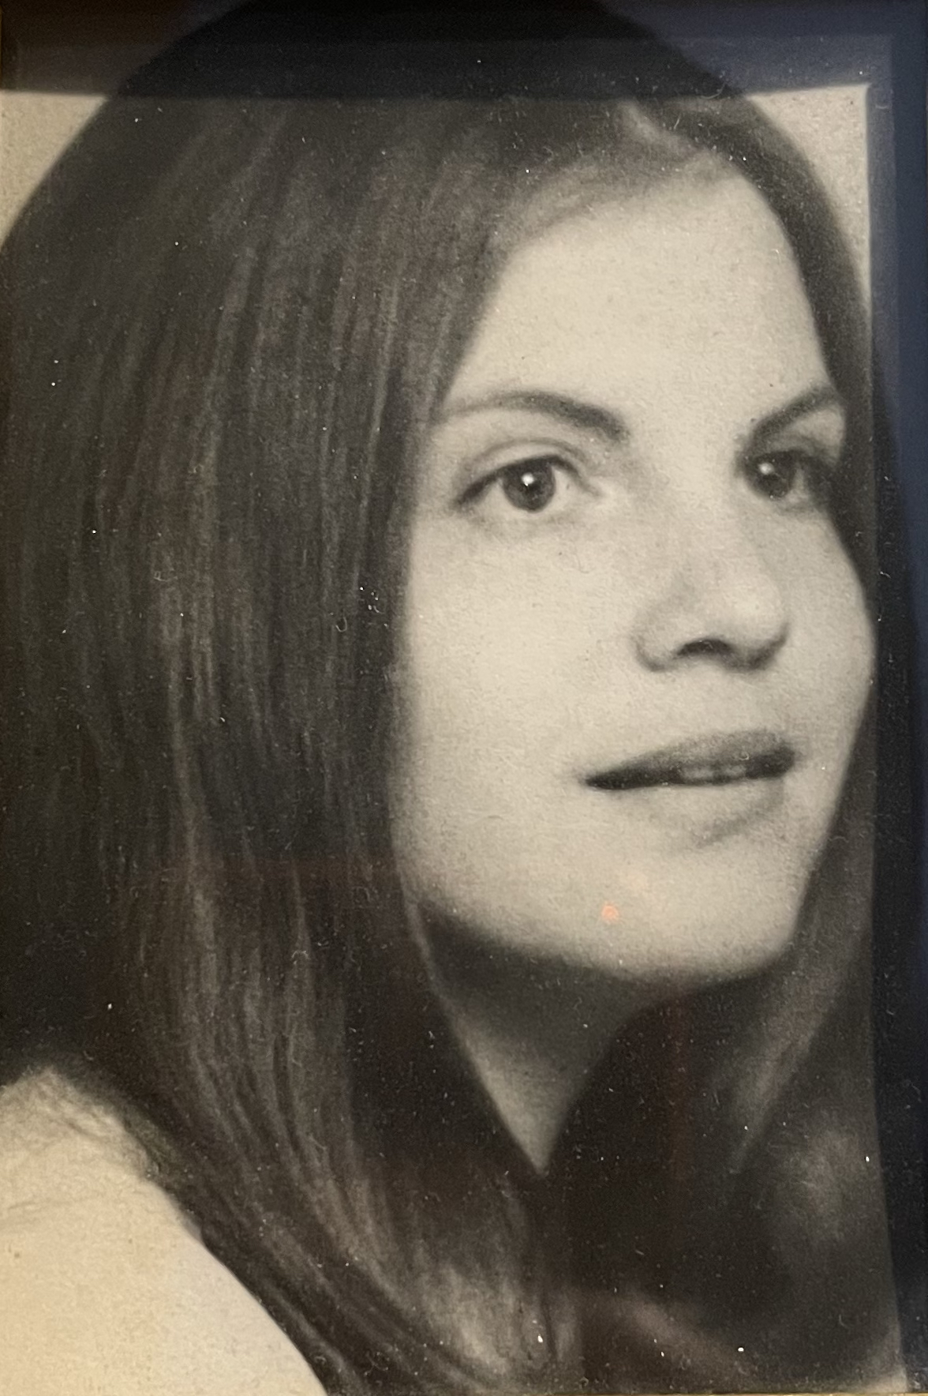
Wann und wie ist Henriette aus der DDR nach Hamburg gekommen?

Einige Zeitzeug:innen haben etwas an der Trostbrücke 1 zu sagen. Was sind die Erinnerungen und Erfahrungen von Henriette? Aufgabe: Tragt in die Sprechblasen ein, was Henriette zur Trostbrücke 1 zu sagen hat.
Aufgabe: Beantwortet folgende Fragen zur Person:
Henriette vor ihrer Inhaftierung Anfang der 1970er Jahre (Copyright: Zeitzeugin Henriette)
https://orte-der-unsichtbarkeit.de/zeitzeuginnen/

_______________________________________________________________________________________

_______________________________________________________________________________________

_______________________________________________________________________________________

_______________________________________________________________________________________

_______________________________________________________________________________________

_______________________________________________________________________________________

_______________________________________________________________________________________

_______________________________________________________________________________________

_______________________________________________________________________________________

_______________________________________________________________________________________

_______________________________________________________________________________________

War/ist Hamburg für Henriette ein Sehnsuchtsort?

_______________________________________________________________________________________

_______________________________________________________________________________________

_______________________________________________________________________________________

_______________________________________________________________________________________

_______________________________________________________________________________________

_______________________________________________________________________________________

_______________________________________________________________________________________
Aufgabe: Welchen Themen lassen sich Henriette zuordnen? Entscheidet euch für ein Thema der Infobox und begründet eure Antwort.

_______________________________________________________________________________________

_______________________________________________________________________________________

_______________________________________________________________________________________

_______________________________________________________________________________________

_______________________________________________________________________________________

_______________________________________________________________________________________

_______________________________________________________________________________________

_______________________________________________________________________________________

_______________________________________________________________________________________

_______________________________________________________________________________________

_______________________________________________________________________________________

______________________________________________________________________________________

_______________________________________________________________________________________

_______________________________________________________________________________________

_______________________________________________________________________________________

_______________________________________________________________________________________

_______________________________________________________________________________________

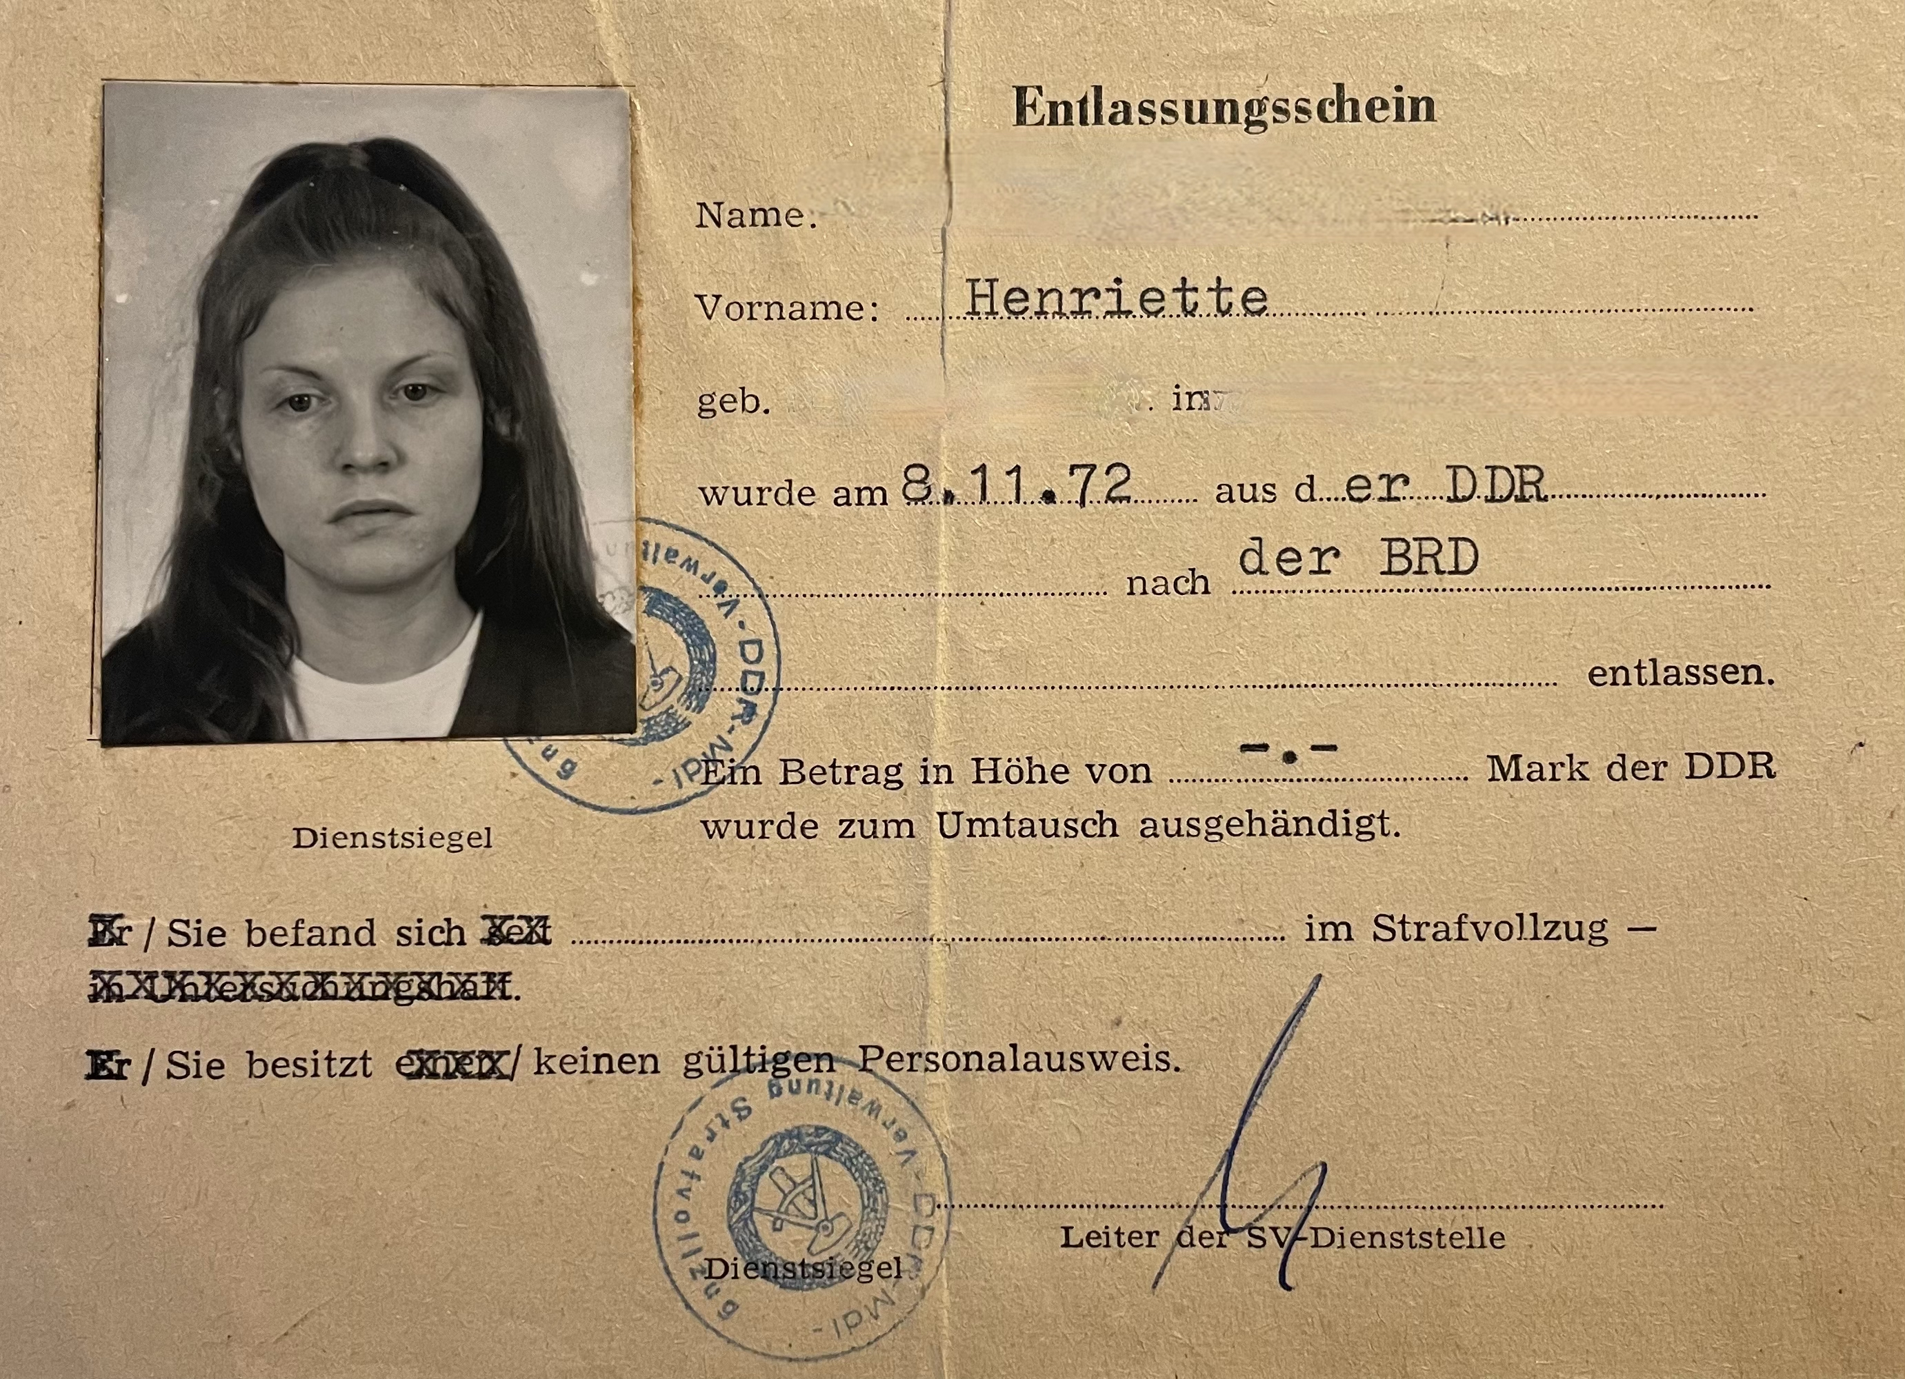
_______________________________________________________________________________________
Aufgabe: Hier könnt ihr notieren, was ihr noch nicht verstanden habt oder ihr sonst noch an der Station spannend findet.
Aufgabe: Ordnet die abgedruckte Quelle vor dem Hintergrund der Station, der Infobox und der Geschichte der Person ein.
Der Entlassungsschein von Henriette (Copyright: Zeitzeugin Henriette)

_______________________________________________________________________________________

_______________________________________________________________________________________

_______________________________________________________________________________________

