Tour 5, Station15: CVJM
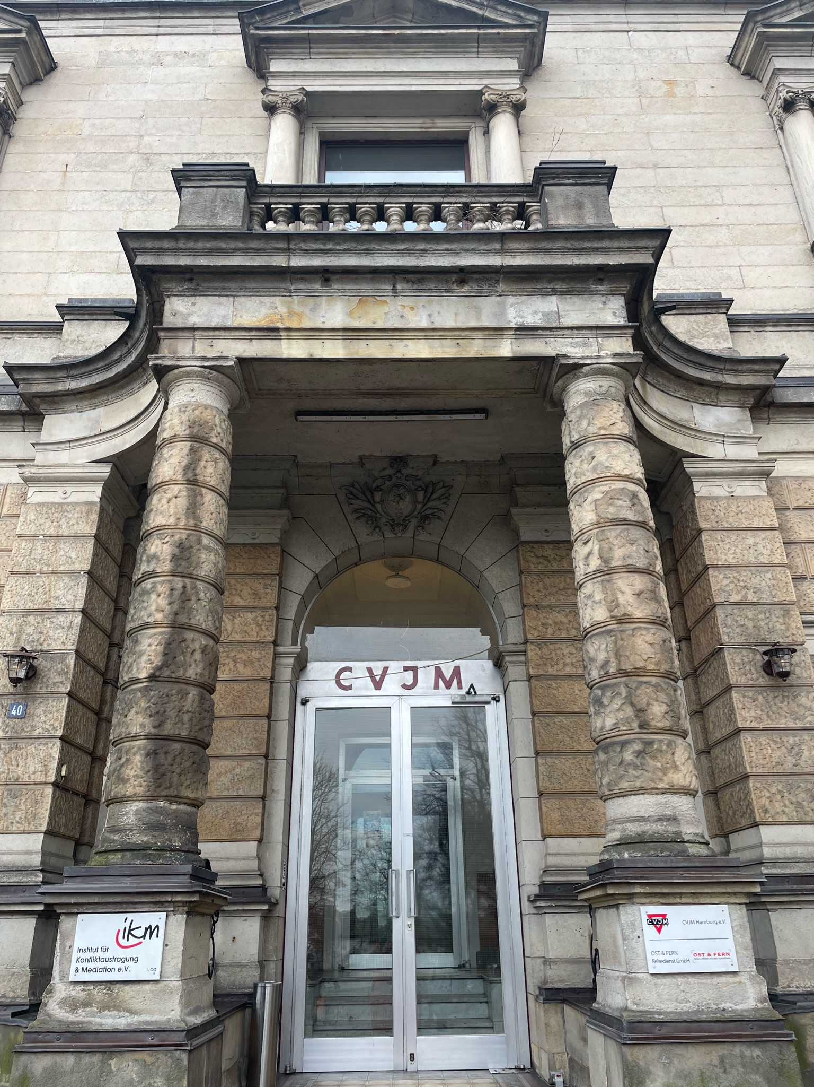

Eingangsbereich des CVJM an der Alster (Copyright: Theresa Hertrich)
https://orte-der-unsichtbarkeit.de/station/cvjm/

Was erfahrt ihr über den Ort CVJM?

_______________________________________________________________________________________

_______________________________________________________________________________________

_______________________________________________________________________________________

_______________________________________________________________________________________

Was hat dieser Ort mit der DDR zu tun?

_______________________________________________________________________________________

_______________________________________________________________________________________
Aufgabe: Hört und schaut euch die Station CVJM an. Beantwortet die folgenden Fragen in Stichworten.

_______________________________________________________________________________________

_______________________________________________________________________________________

Welches Thema findet ihr an diesem Ort besonders wichtig?

_______________________________________________________________________________________

_______________________________________________________________________________________

_______________________________________________________________________________________

_______________________________________________________________________________________

Wie hat Peter die DDR wahrgenommen? Wie beschreibt er seine Lebensverhältnisse?

_______________________________________________________________________________________

_______________________________________________________________________________________

_______________________________________________________________________________________

_______________________________________________________________________________________

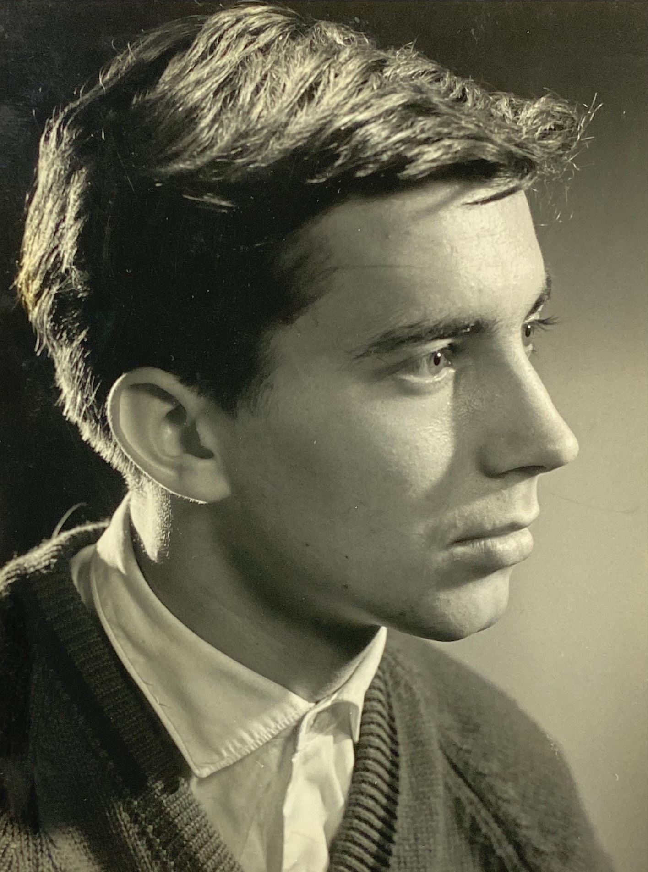
Wann und wie ist Peter aus der DDR nach Hamburg gekommen?

Einige Zeitzeug:innen haben etwas zum CVJM zu sagen. Was sind die Erinnerungen und Erfahrungen von Peter? Aufgabe: Tragt in die Sprechblasen ein, was Peter zum CVJM zu sagen hat.
Aufgabe: Beantwortet folgende Fragen zur Person:
Peter kurz nach seiner Flucht 1960 (Copyright: Zeitzeuge Peter)
https://orte-der-unsichtbarkeit.de/zeitzeuginnen/

_______________________________________________________________________________________

_______________________________________________________________________________________

_______________________________________________________________________________________

_______________________________________________________________________________________

_______________________________________________________________________________________

_______________________________________________________________________________________

_______________________________________________________________________________________

_______________________________________________________________________________________

_______________________________________________________________________________________

_______________________________________________________________________________________

_______________________________________________________________________________________

War/ist Hamburg für Peter ein Sehnsuchtsort?

_______________________________________________________________________________________

_______________________________________________________________________________________

_______________________________________________________________________________________

_______________________________________________________________________________________

_______________________________________________________________________________________

_______________________________________________________________________________________

_______________________________________________________________________________________
Aufgabe: Welche Themen lassen sich Peter zuordnen? Entscheidet euch für ein Thema der Infobox und begründet eure Antwort.

_______________________________________________________________________________________

_______________________________________________________________________________________

_______________________________________________________________________________________

_______________________________________________________________________________________

_______________________________________________________________________________________

_______________________________________________________________________________________

_______________________________________________________________________________________

_______________________________________________________________________________________

_______________________________________________________________________________________

_______________________________________________________________________________________

_______________________________________________________________________________________

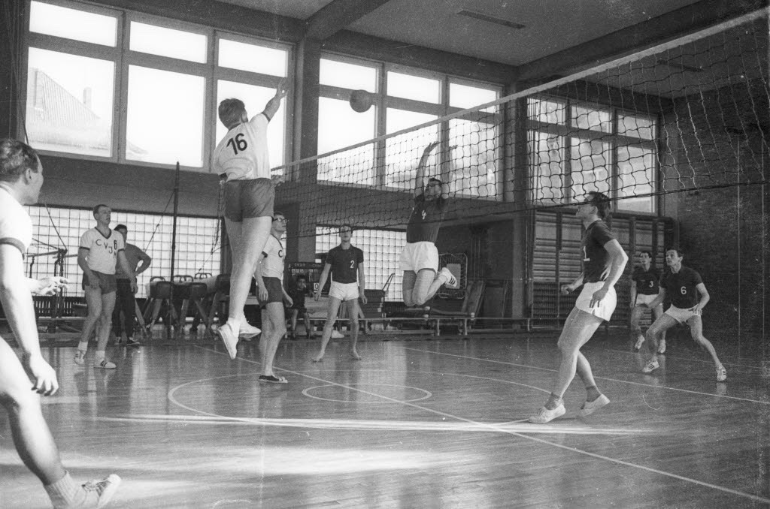
______________________________________________________________________________________

_______________________________________________________________________________________

_______________________________________________________________________________________

_______________________________________________________________________________________

_______________________________________________________________________________________

_______________________________________________________________________________________

_______________________________________________________________________________________
Aufgabe: Hier könnt ihr notieren, was ihr noch nicht verstanden habt oder ihr sonst noch an der Station spannend findet.
Aufgabe: Ordnet die abgedruckte Quelle vor dem Hintergrund der Station, der Infoboxen und der Geschichte der Person ein.
Ein Volleyballspiel der Mannschaft des CVJM im Februar 1965. (Copyright: Stadtarchiv Kiel, Friedrich Magnussen)

_______________________________________________________________________________________

_______________________________________________________________________________________

