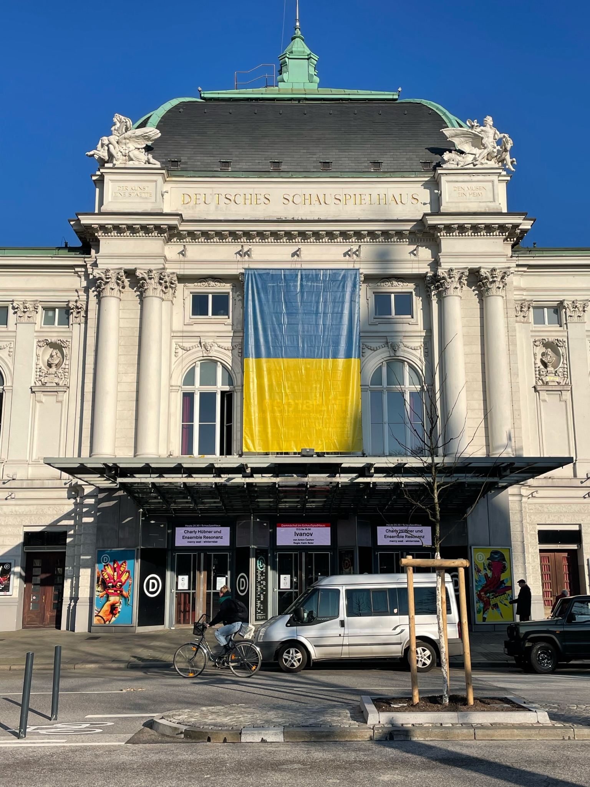
Tour 5, Station 14: Schauspielhaus

https://orte-der-unsichtbarkeit.de/station/schauspielhaus-bieberhaus/
Aktuelle Aufnahme des Schauspielhauses (Copyright: Theresa Hertrich)

Was erfahrt ihr über den Ort Schauspielhaus?

_______________________________________________________________________________________

_______________________________________________________________________________________

_______________________________________________________________________________________

_______________________________________________________________________________________

Was hat dieser Ort mit der DDR zu tun?

_______________________________________________________________________________________

_______________________________________________________________________________________
Aufgabe: Hört und schaut euch die Station Schauspielhaus an. Beantwortet die folgenden Fragen in Stichworten.

_______________________________________________________________________________________

_______________________________________________________________________________________

Welches Thema findet ihr an diesem Ort besonders wichtig?

_______________________________________________________________________________________

_______________________________________________________________________________________

_______________________________________________________________________________________

_______________________________________________________________________________________

Wie hat Ingeborg die DDR wahrgenommen? Wie beschreibt sie ihre Lebensverhältnisse?

_______________________________________________________________________________________

_______________________________________________________________________________________

_______________________________________________________________________________________

_______________________________________________________________________________________

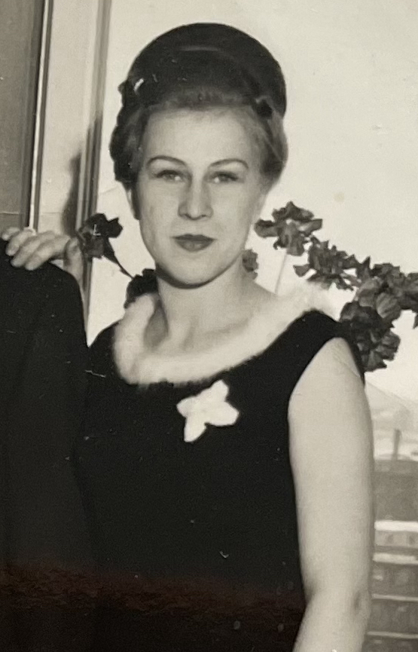
Wann und wie ist Ingeborg aus der DDR nach Hamburg gekommen?

Einige Zeitzeug:innen haben etwas zum Schauspielhaus zu sagen. Was sind die Erinnerungen und Erfahrungen von Ingeborg? Aufgabe: Tragt in die Sprechblasen ein, was Ingeborg zum Schauspielhaus zu sagen hat.
Aufgabe: Beantwortet folgende Fragen zur Person:
Ingeborg Ende der 1950er Jahre (Copyright: Zeitzeugin Ingeborg)
https://orte-der-unsichtbarkeit.de/zeitzeuginnen/

_______________________________________________________________________________________

_______________________________________________________________________________________

_______________________________________________________________________________________

_______________________________________________________________________________________

_______________________________________________________________________________________

_______________________________________________________________________________________

_______________________________________________________________________________________

_______________________________________________________________________________________

_______________________________________________________________________________________

_______________________________________________________________________________________

_______________________________________________________________________________________

War/ist Hamburg für Ingeborg ein Sehnsuchtsort?

_______________________________________________________________________________________

_______________________________________________________________________________________

_______________________________________________________________________________________

_______________________________________________________________________________________

_______________________________________________________________________________________

_______________________________________________________________________________________
Aufgabe: Hier könnt ihr notieren, was ihr noch nicht verstanden habt oder ihr sonst noch an der Station spannend findet.

_______________________________________________________________________________________

_______________________________________________________________________________________

_______________________________________________________________________________________

_______________________________________________________________________________________

_______________________________________________________________________________________

_______________________________________________________________________________________

_______________________________________________________________________________________

_______________________________________________________________________________________

_______________________________________________________________________________________

_______________________________________________________________________________________

