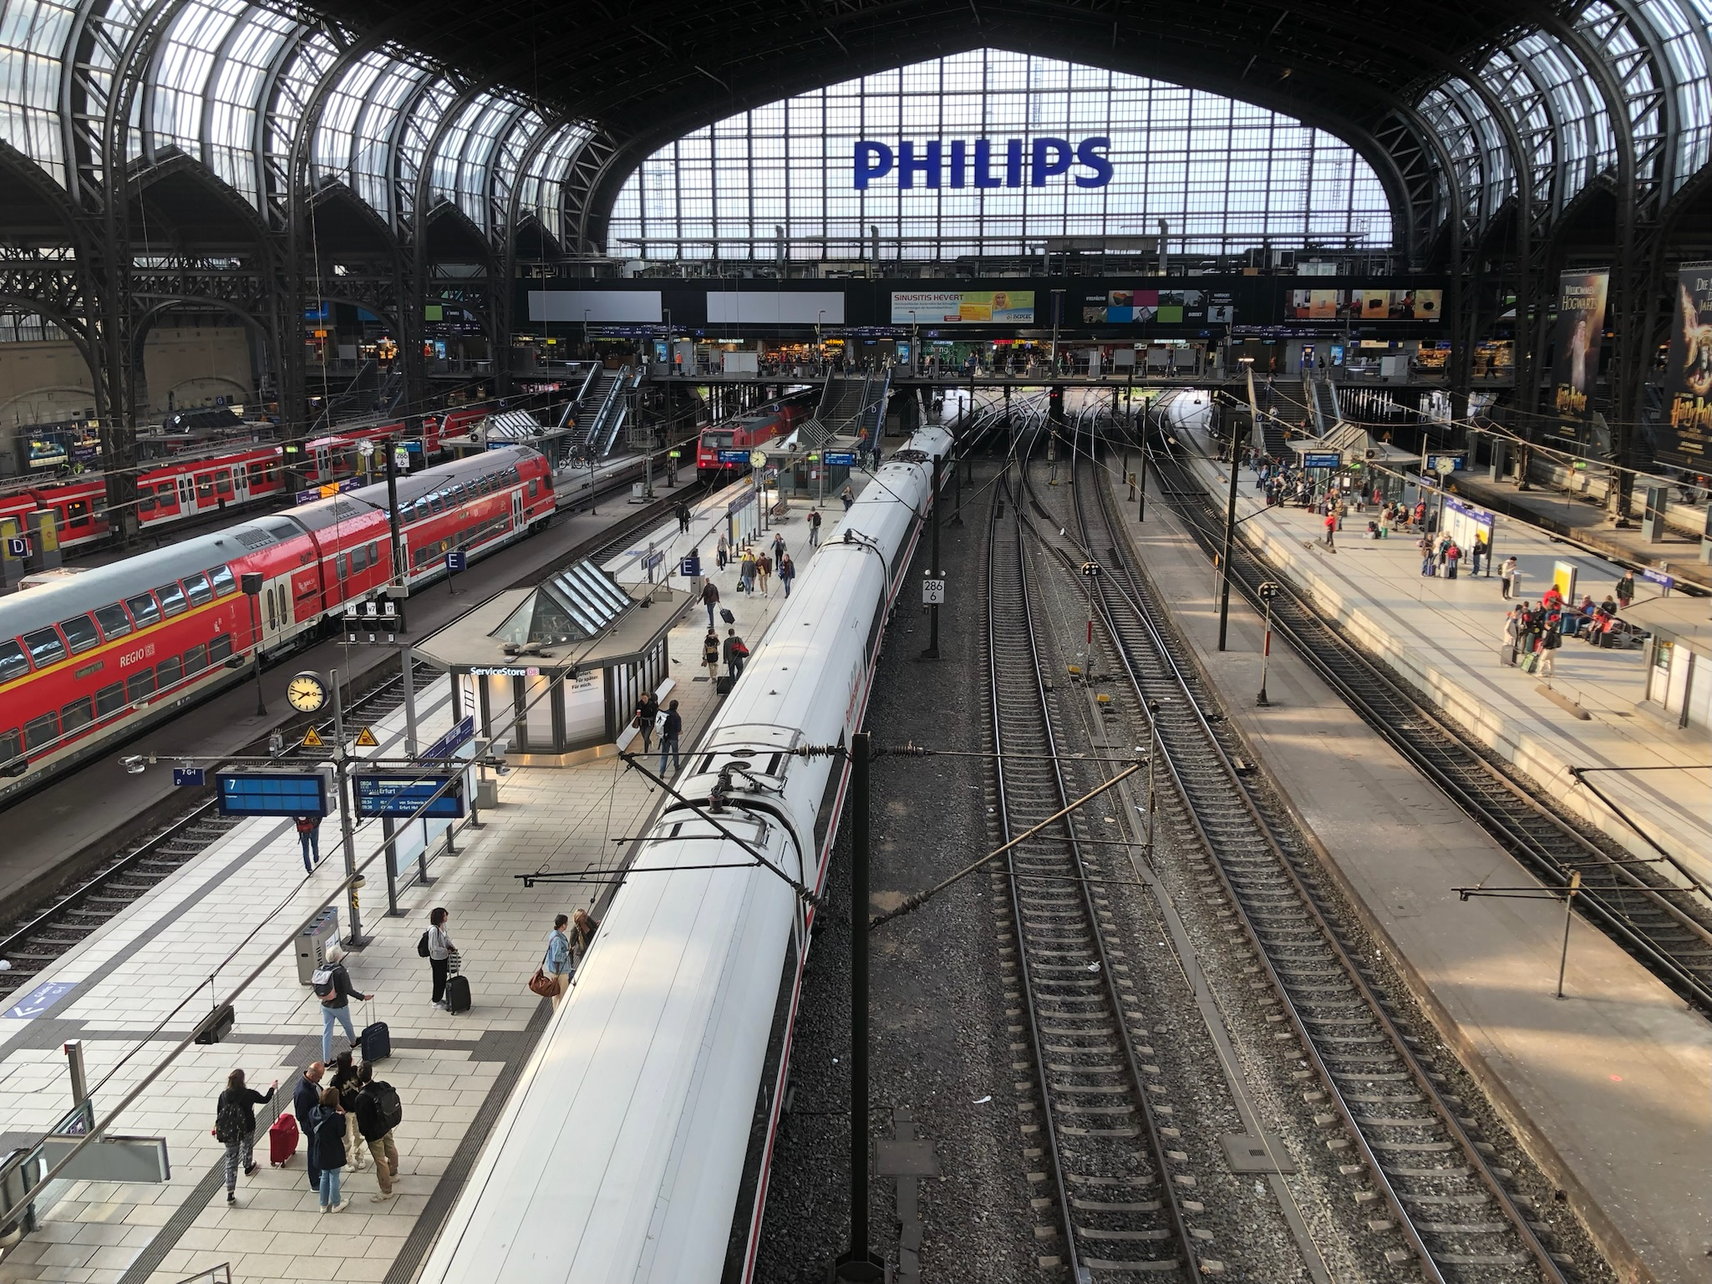
Tour 5, Station 13: Hauptbahnhof

https://orte-der-unsichtbarkeit.de/station/hauptbahnhof/
Blick auf die Gleise des Hamburger Hauptbahnhofs (Copyright: Jan Krawczyk)

Was erfahrt ihr über den Ort Hauptbahnhof?

_______________________________________________________________________________________

_______________________________________________________________________________________

_______________________________________________________________________________________

_______________________________________________________________________________________

Was hat dieser Ort mit der DDR zu tun?

_______________________________________________________________________________________

_______________________________________________________________________________________
Aufgabe: Hört und schaut euch die Station Hauptbahnhof an. Beantwortet die folgenden Fragen in Stichworten.

_______________________________________________________________________________________

_______________________________________________________________________________________

Welches Thema findet ihr an diesem Ort besonders wichtig?

_______________________________________________________________________________________

_______________________________________________________________________________________

_______________________________________________________________________________________

_______________________________________________________________________________________

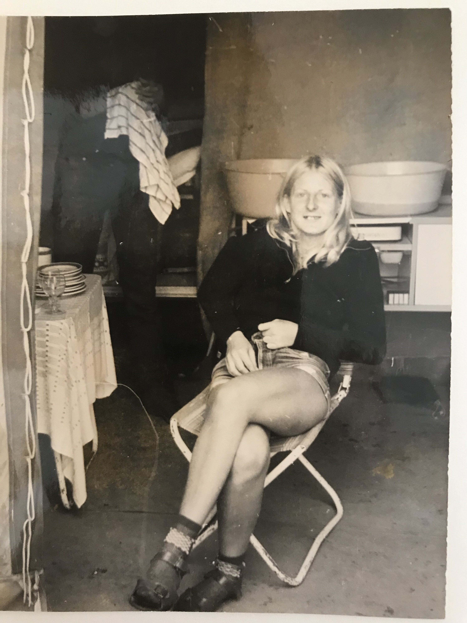
https://orte-der-unsichtbarkeit.de/zeitzeuginnen/

Wie haben Grit und Charlotte die DDR wahrgenommen? Wie beschreiben sie ihre Lebensverhältnisse?

_______________________________________________________________________________________

_______________________________________________________________________________________

_______________________________________________________________________________________

_______________________________________________________________________________________

Wann und wie sind Grit und Charlotte aus der DDR nach Hamburg gekommen?

Einige Zeitzeug:innen haben etwas zum Hauptbahnhof zu sagen. Was sind die Erinnerungen und Erfahrungen von Grit und Charlotte? Aufgabe: Tragt in die Sprechblasen ein, was Grit und Charlotte zum Hauptbahnhof zu sagen haben.
Aufgabe: Beantwortet folgende Fragen zu Grit und Charlotte:
Grit im Alter von 16 Jahren kurz vor ihrer Ausreise nach Hamburg (Copyright: Zeitzeugin Grit)

_______________________________________________________________________________________

_______________________________________________________________________________________

_______________________________________________________________________________________

_______________________________________________________________________________________

_______________________________________________________________________________________

_______________________________________________________________________________________

_______________________________________________________________________________________

_______________________________________________________________________________________

_______________________________________________________________________________________

_______________________________________________________________________________________

_______________________________________________________________________________________

War/ist Hamburg für Grit und Charlotte ein Sehnsuchtsort?

_______________________________________________________________________________________

_______________________________________________________________________________________

_______________________________________________________________________________________

_______________________________________________________________________________________

_______________________________________________________________________________________

_______________________________________________________________________________________

_______________________________________________________________________________________
Aufgabe: Welche Themen lassen sich Grit und Charlotte zuordnen? Entscheidet euch für ein Thema der Infobox und begründet eure Antwort.

_______________________________________________________________________________________

_______________________________________________________________________________________

_______________________________________________________________________________________

_______________________________________________________________________________________

_______________________________________________________________________________________

_______________________________________________________________________________________

_______________________________________________________________________________________

_______________________________________________________________________________________

_______________________________________________________________________________________

_______________________________________________________________________________________

_______________________________________________________________________________________

_______________________________________________________________________________________

_______________________________________________________________________________________

_______________________________________________________________________________________

_______________________________________________________________________________________

_______________________________________________________________________________________

_______________________________________________________________________________________

_______________________________________________________________________________________
Aufgabe: Hier könnt ihr notieren, was ihr noch nicht verstanden habt oder ihr sonst noch an der Station spannend findet.

_______________________________________________________________________________________

_______________________________________________________________________________________

_______________________________________________________________________________________

_______________________________________________________________________________________

_______________________________________________________________________________________

