Tour 4, Station 11: Fischmarkt
Aktuelles Bild vom Eingang zum Fischmarkt auf Höhe der St. Pauli Hafenstraße (Copyright: Theresa Hertrich)
https://orte-der-unsichtbarkeit.de/station/fischmarkt/
Was erfahrt ihr über den Ort Fischmarkt?

_______________________________________________________________________________________

_______________________________________________________________________________________

_______________________________________________________________________________________

_______________________________________________________________________________________

Was hat dieser Ort mit der DDR zu tun?

_______________________________________________________________________________________

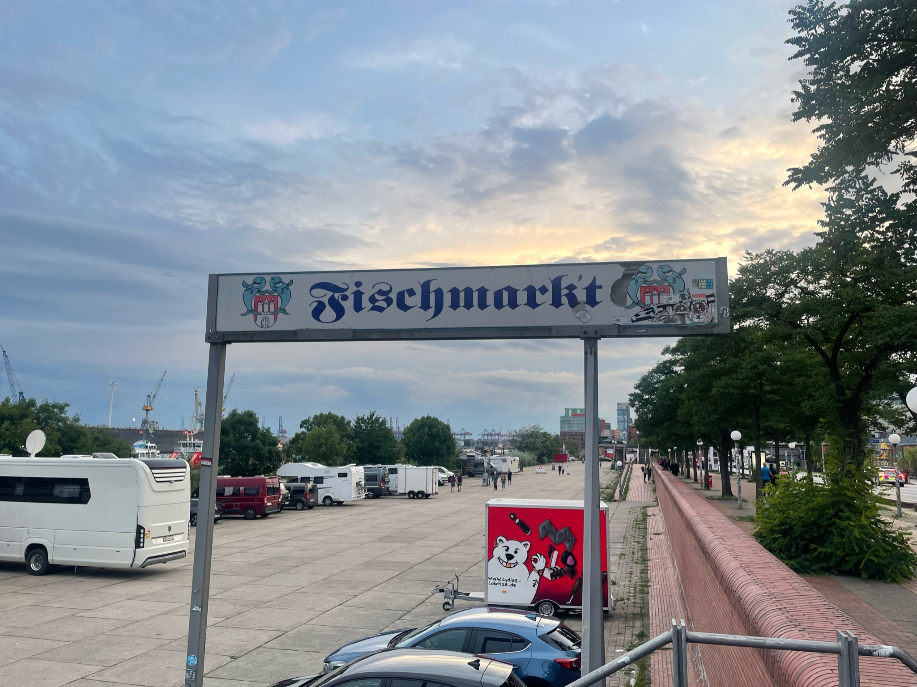
_______________________________________________________________________________________
Aufgabe: Hört und schaut euch die Station Fischmarkt an. Beantwortet die folgenden Fragen in Stichworten.

_______________________________________________________________________________________

_______________________________________________________________________________________

Welches Thema findet ihr an diesem Ort besonders wichtig?

_______________________________________________________________________________________

_______________________________________________________________________________________

_______________________________________________________________________________________

_______________________________________________________________________________________

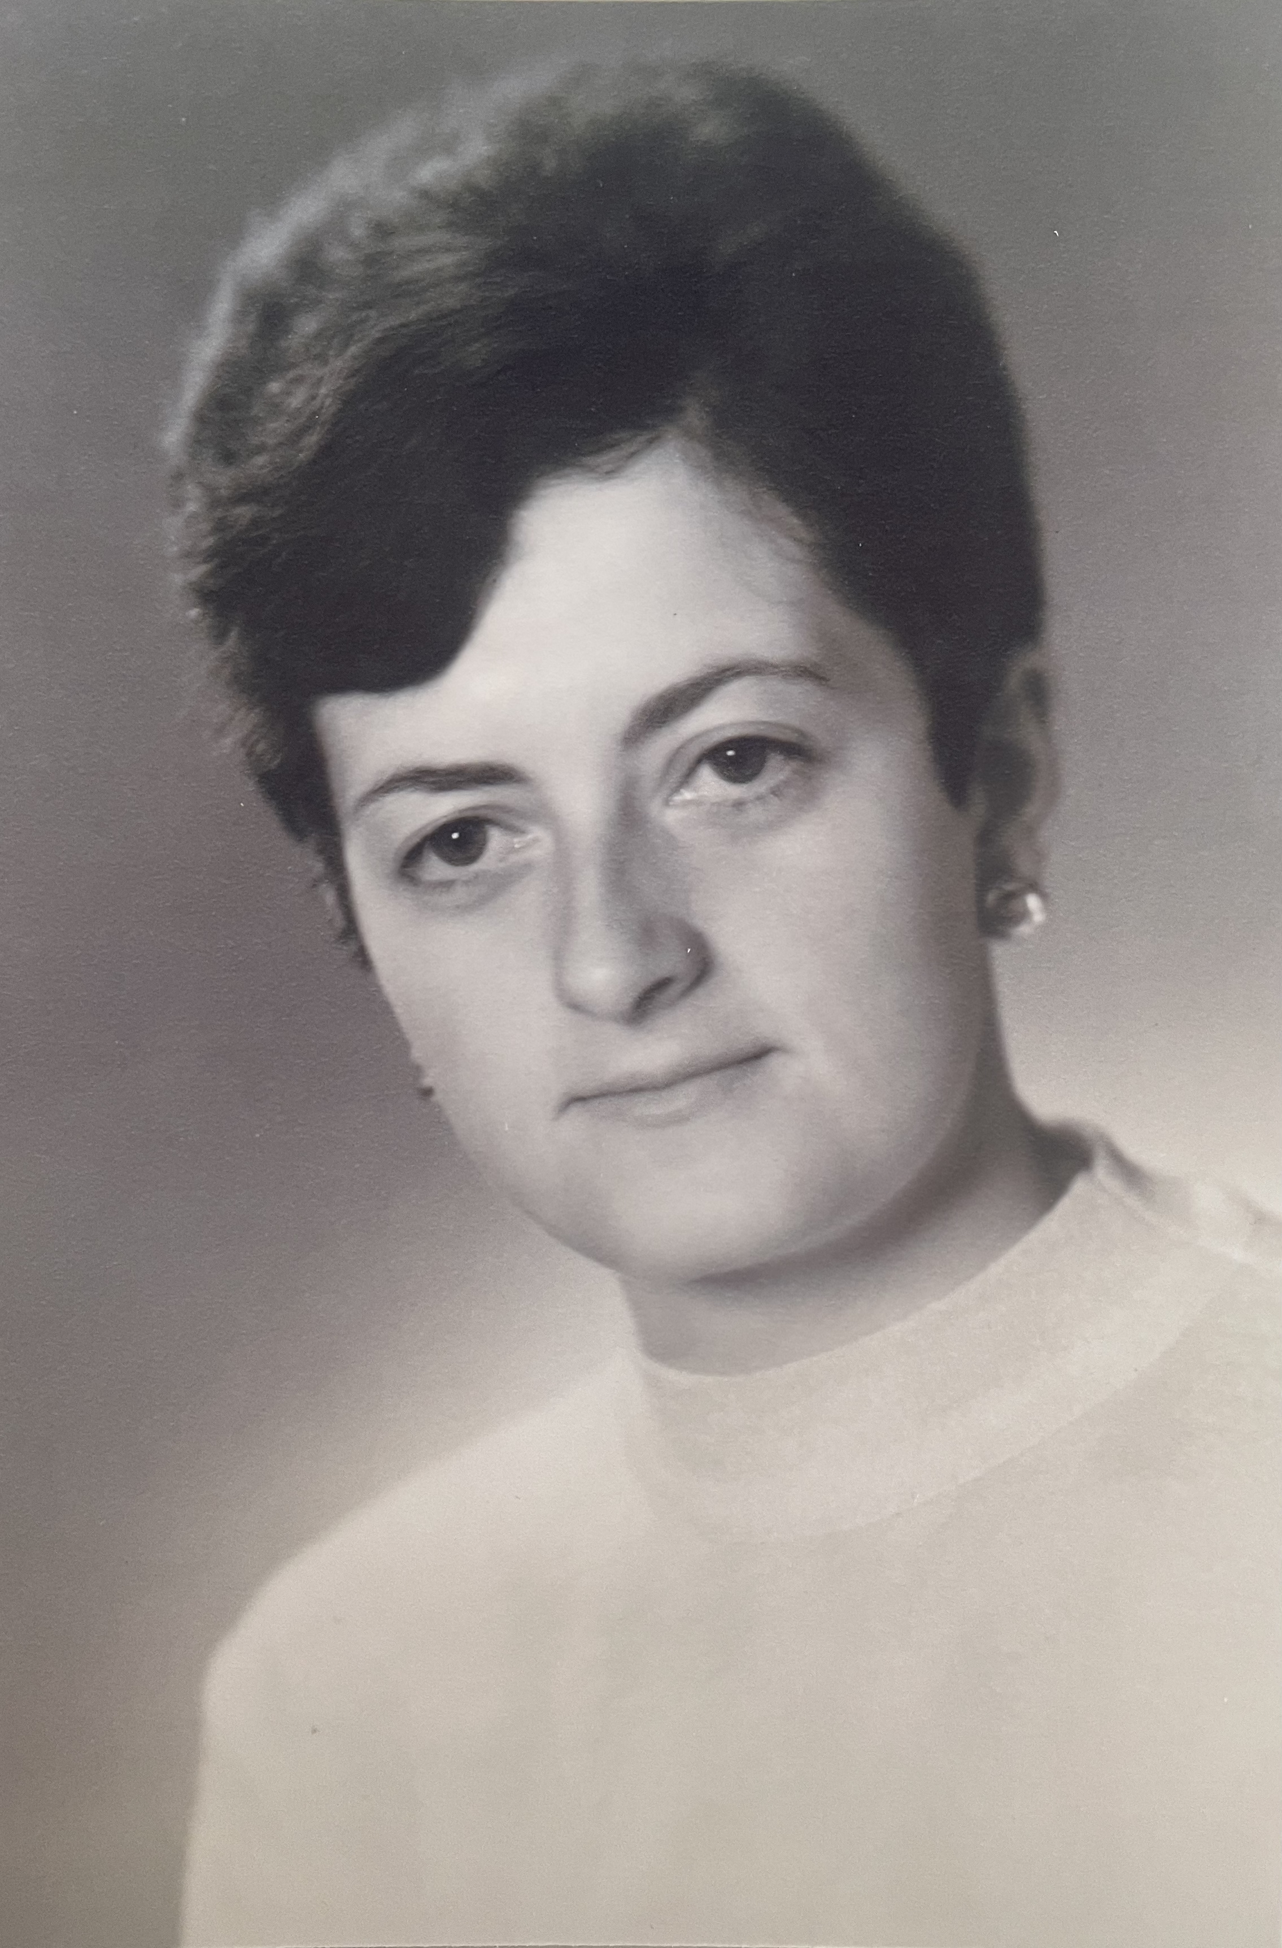
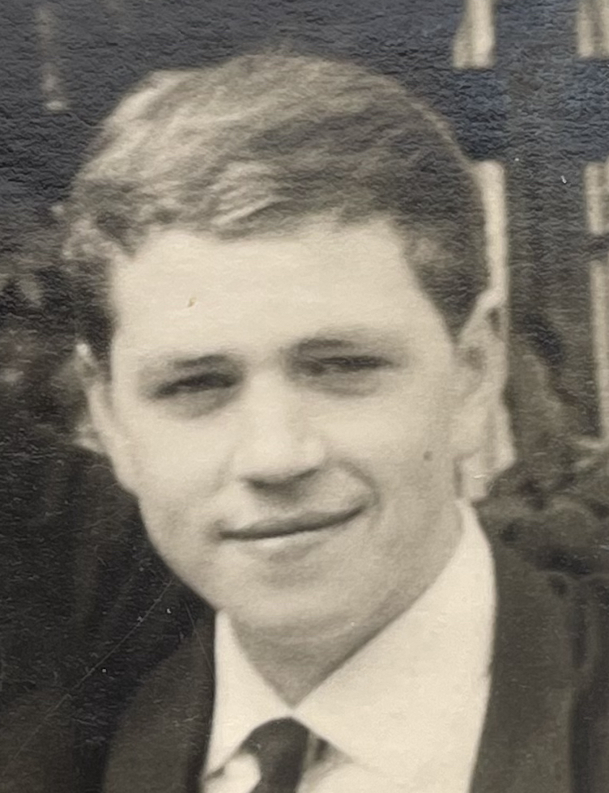

Einige Zeitzeug:innen haben etwas zum Fischmarkt zu sagen. Was sind die Erinnerungen und Erfahrungen von Evelin und Günter? Aufgabe: Tragt in die Sprechblasen ein, was die Personen zum Fischmarkt sagen.
Günter Mitte der 1960er Jahre (Copyright: Zeitzeuge Günter)
Evelin Anfang der 1970er Jahre (Copyright: Zeitzeugin Evelin)

Aufgabe: Entscheidet euch nun für eine Person und beantwortet folgende Fragen:

Wie hat die Person die DDR wahrgenommen? Wie beschreibt sie ihre Lebensverhältnisse?

_______________________________________________________________________________________

_______________________________________________________________________________________

_______________________________________________________________________________________

_______________________________________________________________________________________

Wann und wie ist die Person aus der DDR nach Hamburg gekommen?

_______________________________________________________________________________________

_______________________________________________________________________________________

_______________________________________________________________________________________

_______________________________________________________________________________________
https://orte-der-unsichtbarkeit.de/zeitzeuginnen/

_______________________________________________________________________________________

_______________________________________________________________________________________

_______________________________________________________________________________________

War/ist Hamburg für die Person ein Sehnsuchtsort?

_______________________________________________________________________________________

_______________________________________________________________________________________

_______________________________________________________________________________________

_______________________________________________________________________________________

_______________________________________________________________________________________

_______________________________________________________________________________________

_______________________________________________________________________________________

_______________________________________________________________________________________

_______________________________________________________________________________________

_______________________________________________________________________________________

_______________________________________________________________________________________

_______________________________________________________________________________________

_______________________________________________________________________________________

_______________________________________________________________________________________

_______________________________________________________________________________________

_______________________________________________________________________________________

_______________________________________________________________________________________

_______________________________________________________________________________________
Aufgabe: Welche Themen lassen sich eurer Person zuordnen? Entscheidet euch für ein Thema der Infobox und begründet eure Antwort.

_______________________________________________________________________________________

_______________________________________________________________________________________

_______________________________________________________________________________________

_______________________________________________________________________________________

_______________________________________________________________________________________

_______________________________________________________________________________________

_______________________________________________________________________________________
Aufgabe: Hier könnt ihr notieren, was ihr noch nicht verstanden habt oder ihr sonst noch an der Station spannend findet.

_______________________________________________________________________________________

_______________________________________________________________________________________

_______________________________________________________________________________________

_______________________________________________________________________________________

