Tour 4, Station 10: Casa Marina
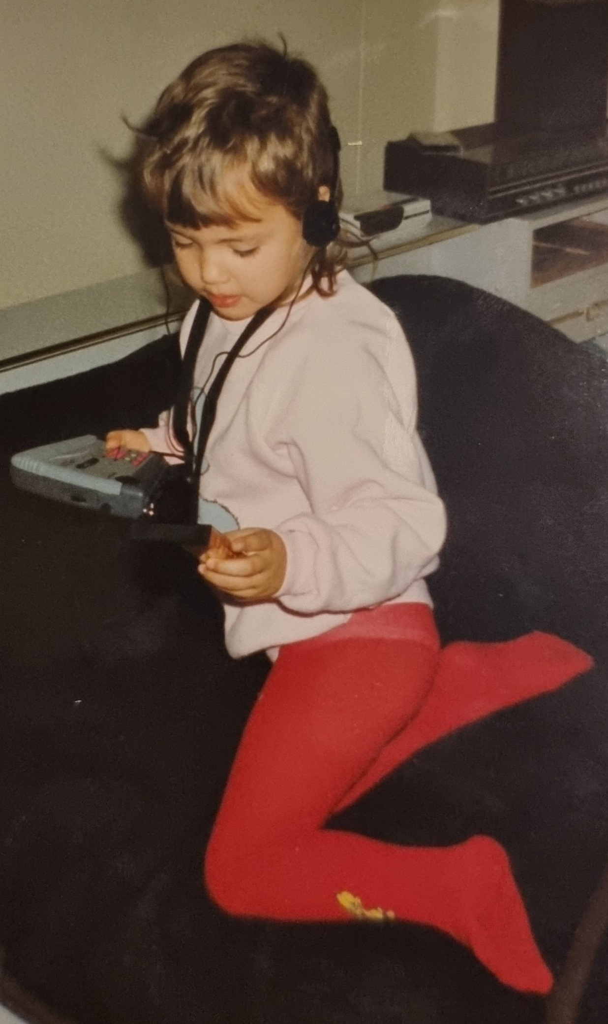

Das Foto zeigt Sarah Victoria in der Kabine auf der Casa Marina, in der sie mit ihrer Familie für rund sechs Wochen gelebt hat. (Copyright: Zeitzeugin Sarah Victoria)
https://orte-der-unsichtbarkeit.de/station/casa-marina/

Was erfahrt ihr über den Ort Casa Marina?

_______________________________________________________________________________________

_______________________________________________________________________________________

_______________________________________________________________________________________

_______________________________________________________________________________________

Was hat dieser Ort mit der DDR zu tun?

_______________________________________________________________________________________

_______________________________________________________________________________________
Aufgabe: Hört und schaut euch die Station Casa Marina an. Beantwortet die folgenden Fragen in Stichworten.

_______________________________________________________________________________________

_______________________________________________________________________________________

Welches Thema findet ihr an diesem Ort besonders wichtig?

_______________________________________________________________________________________

_______________________________________________________________________________________

_______________________________________________________________________________________

Wie hat Sarah Victoria die DDR wahrgenommen? Wie beschreibt sie ihre Lebensverhältnisse?

_______________________________________________________________________________________

_______________________________________________________________________________________

_______________________________________________________________________________________

_______________________________________________________________________________________

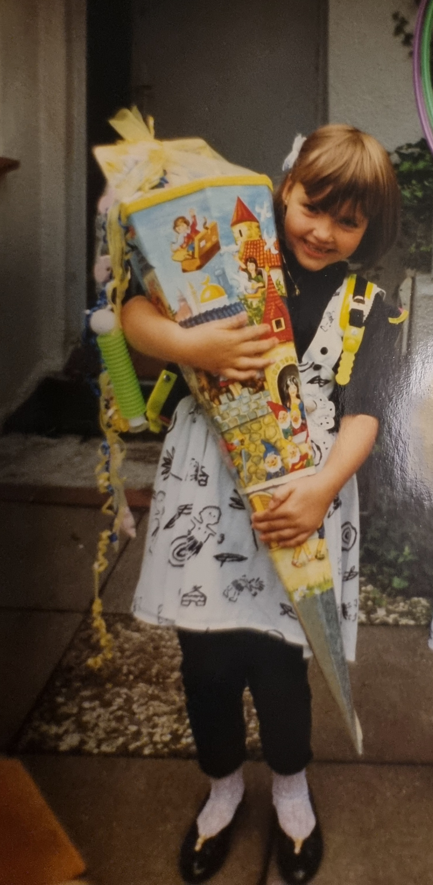
Wann und wie ist Sarah Victoria aus der DDR nach Hamburg gekommen?

Einige Zeitzeug:innen haben etwas an der Station Casa Marina zu sagen. Was sind die Erinnerungen und Erfahrungen von Sarah Victoria? Aufgabe: Tragt in die Sprechblasen ein, was Sarah Victoria zur Casa Marina zu sagen hat.
Aufgabe: Beantwortet folgende Fragen zur Person:
Foto von Sarah Victoria bei ihrer Einschulung 1991 (Copyright: Zeitzeugin Sarah Victoria)
https://orte-der-unsichtbarkeit.de/zeitzeuginnen/

_______________________________________________________________________________________

_______________________________________________________________________________________

_______________________________________________________________________________________

_______________________________________________________________________________________

_______________________________________________________________________________________

_______________________________________________________________________________________

_______________________________________________________________________________________

_______________________________________________________________________________________

_______________________________________________________________________________________

_______________________________________________________________________________________

_______________________________________________________________________________________

War/ist Hamburg für Sarah Victoria ein Sehnsuchtsort?

_______________________________________________________________________________________

_______________________________________________________________________________________

_______________________________________________________________________________________

_______________________________________________________________________________________

_______________________________________________________________________________________

_______________________________________________________________________________________

_______________________________________________________________________________________
Aufgabe: Welche Themen lassen sich Sarah Victoria zuordnen? Entscheidet euch für ein Thema der Infobox und begründet eure Antwort.

_______________________________________________________________________________________

_______________________________________________________________________________________

_______________________________________________________________________________________

_______________________________________________________________________________________

_______________________________________________________________________________________

_______________________________________________________________________________________

_______________________________________________________________________________________

_______________________________________________________________________________________

______________________________________________________________________________________
Die Beauftragung zur Bewachung der Casa Marina an eine Hamburger Sicherheitsfirma vom 05. Oktober 1989 (Copyright: Staatsarchiv Hamburg, 351-19_577 Casa Marina)

_______________________________________________________________________________________

_______________________________________________________________________________________

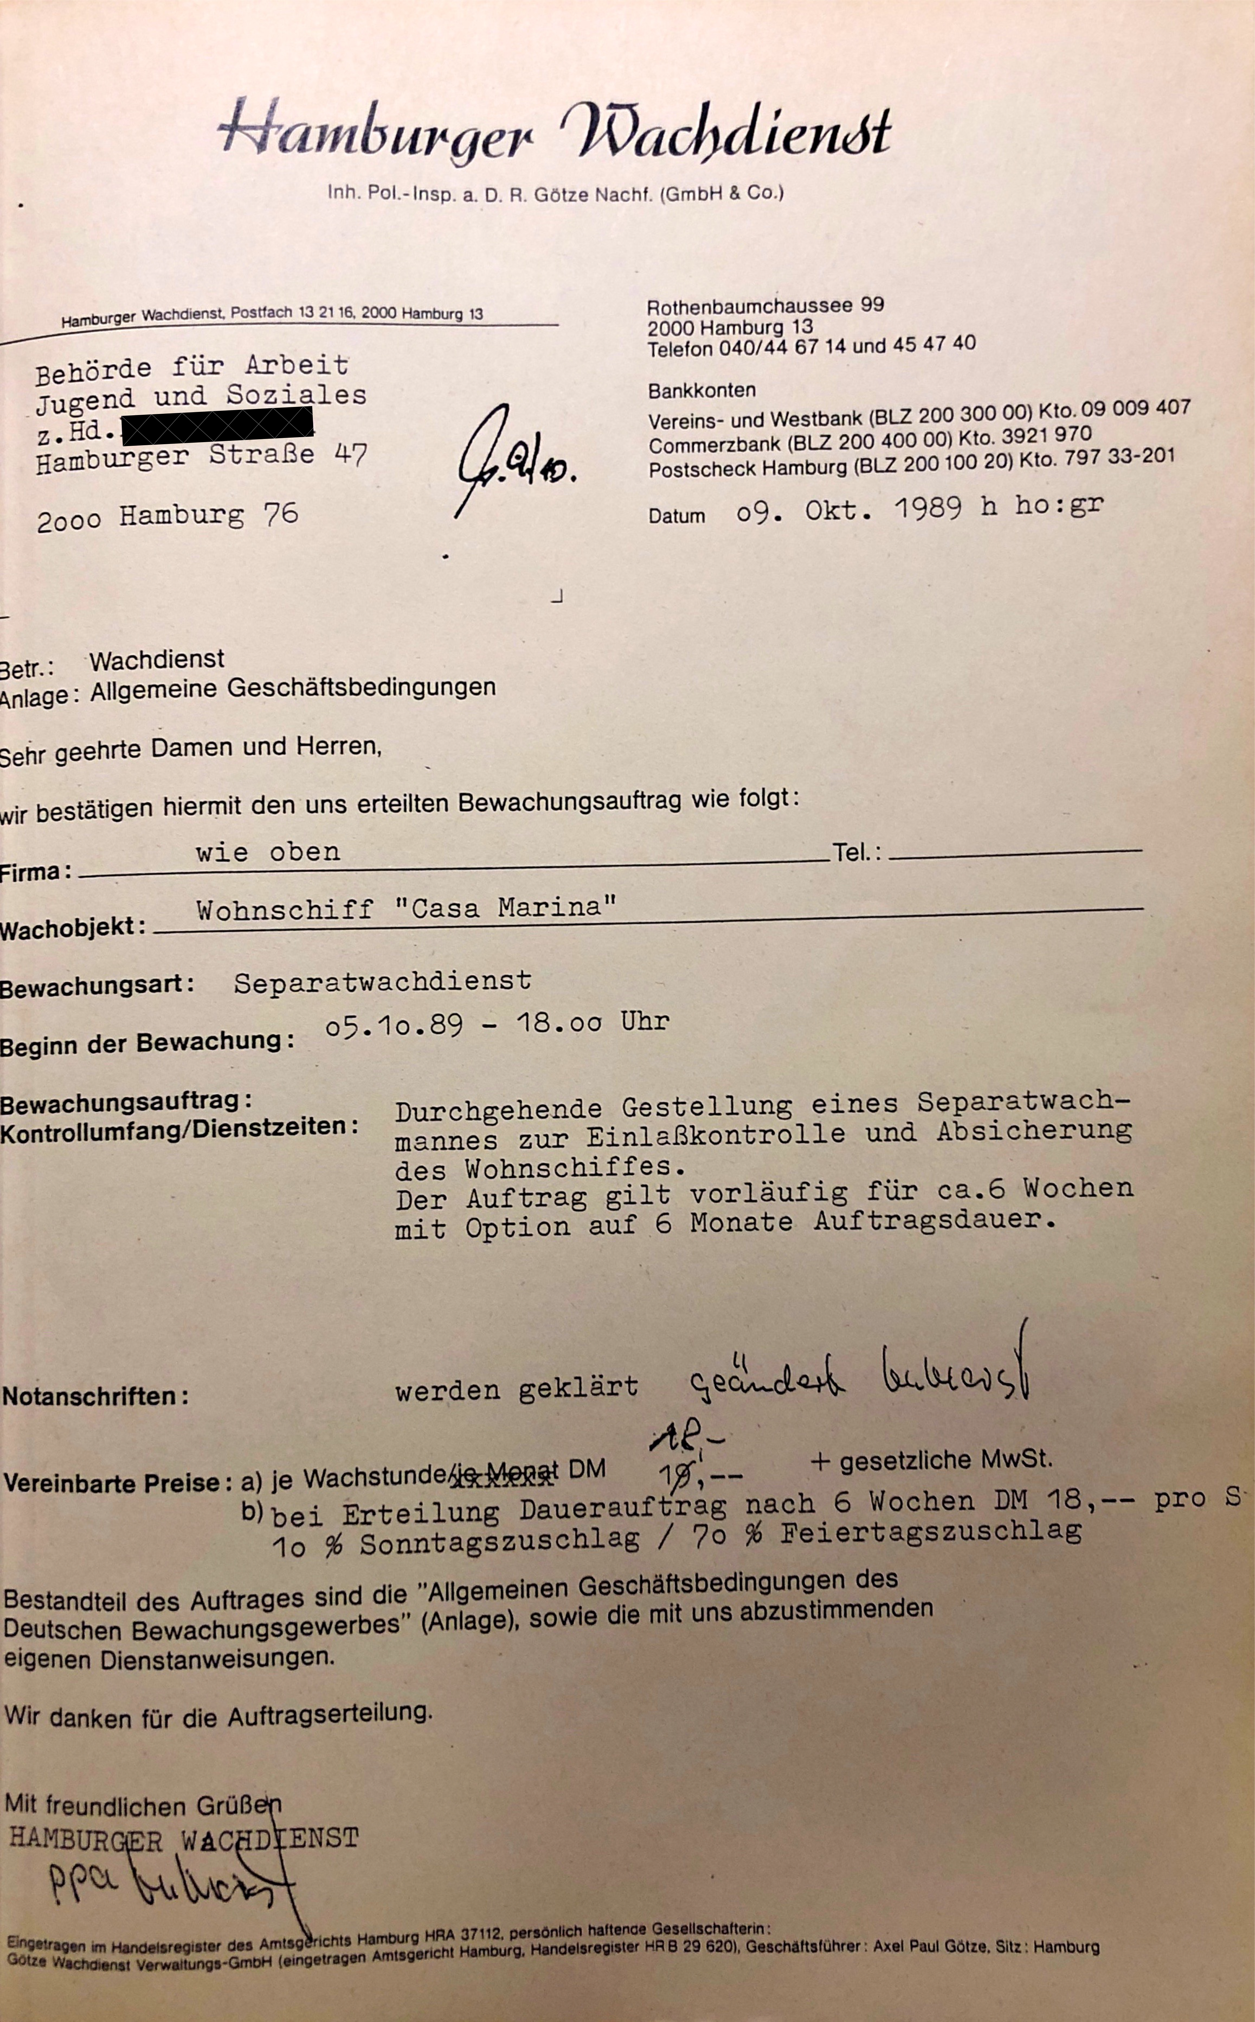
_______________________________________________________________________________________

_______________________________________________________________________________________

_______________________________________________________________________________________

_______________________________________________________________________________________

_______________________________________________________________________________________

_______________________________________________________________________________________
Aufgabe: Hier könnt ihr notieren, was ihr noch nicht verstanden habt oder ihr sonst noch an der Station spannend findet.
Aufgabe: Ordnet die abgedruckte Quelle vor dem Hintergrund der Station, der Infoboxen und der Geschichte der Person ein.
____________________________________________________

____________________________________________________

____________________________________________________

____________________________________________________

____________________________________________________

____________________________________________________

____________________________________________________

____________________________________________________

____________________________________________________

____________________________________________________

____________________________________________________

____________________________________________________

_______________________________________________________________________________________

